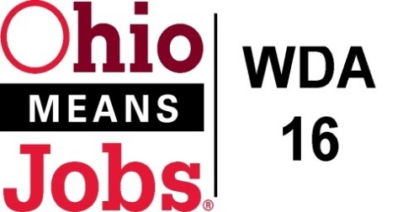
WDA 16

A proud partner of the
American Job Center network

AREA 16 Council of Government (COG)
Minutes
April 6, 2018
Harrison County DJFS

Present: Mark Dr. Graham (Jefferson Co.), Lewis Mickley (Carroll Co.) and
Don Bethel (Harrison Co: Chair)

Visitors: Vince Gianangeli, Betty Ferron, Scott Blackburn, Kate Offenberger, Mike Schlanz, Jennifer Burns, Deb Knight, Mike McGlumphy, Rich Gualtiere, Rebecca Safko, Rob Guentter
- Call to Order:
Meeting called to order by Chairperson, Don Bethel at 1:03pm

- Approval of Minutes:
Motion made to approve the minutes from Feb 2, 2018, as written.
Motion 11-2018 to approve 9/22/17 COG Minutes
1st- Dr. Graham, 2nd- Lewis Mickley Motion Carried

- Financial/Participant Reports (Rebecca)
Motion made to approve the following reports:
- Feb 2018 Financial Report
- Feb 2018 Allocation /Expense Report
Vince and Rebecca were congratulated by the COG for another successful Perfect State Audit!
The letter from Dave Yost, Auditor of State was circulated.

Motion 12-2018 to approve Financial Report
1st- Dr. Graham, 2nd- Lewis Mickley Motion Carried

- Funding Transfers: Administrative Funds to cover: Jefferson Co Youth $858.47 (IN $214.62, OUT $643.85), Adult $770.40, DW $861.13 Total $2,490.00; Harrison Co Adult $24.49, DW $32.78, and Youth $86.73 Total $144.00 The WDB16 approved this transfer on 3/30/18 Motion 03-2018.
Motion 13-2018 to approve these Fund Transfers
1st- Dr. Graham, 2nd- Lewis Mickley Motion Carried

- WIOA Update (Rob)
- Rob reviewed his written staff report and highlighted the upcoming staff Social Media Training, Youth Service 14 Element Procurement is underway, Youth and Adult and DW Framework and Design procurements for Jefferson and Harrison Counties are underway, the BRN grant will be submitted this month, and our WDA16 Rapid Response Plan has been approve d by the State.

There was a discussion about the JFS Directors meeting to review all of the bids after Youth Council review and scoring, to sort out recommendations for WIOA funding vs what the JFSs’ will cover with TANF dollars. A meeting for Staff to the Board and the JFS Directors was set for April 30, 2018 at 8am at the Jefferson Co JFS office.

- County Updates:
- Belmont Co: Mike Schlanz spoke about the very successful Job Fair held in Belmont Co on April 4. It was the largest ever with 141 businesses registered. He also shared that a Veteran “mystery shopper” had a good experience at the Belmont One-Stop.
- Carroll Co: Jennifer shared that Carroll Co is having a Job Fair on May 9 at the County Fairgrounds. This falls within the Governors’ Workforce Transition Offices In-Demand Jobs Week celebrations.
- Harrison and Jefferson Co: Jefferson Co is having their Job Fair on May 16 at Florian Hall. They also reported that their CCMEP program is full for the summer.

- Additional Business
None

- Next Meeting: Friday June 15, 2018 at 1pm at Harrison County DJFS.

- Motion to Adjourn at 1:43pm

Motion 14-2018 to Adjourn 1st-Dr Graham 2nd Lewis Mickley Motion Carried

_________________________________________________ _____________
Board Chair Date

