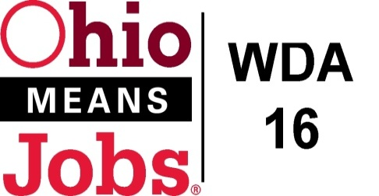
AREA 16 Council of Government (COG)
Minutes
June 23, 2017 Minutes for Sept 22, 2017
Harrison County DJFS

Present: Mark Thomas (Belmont Co), Lewis Mickley (Carroll Co.) and
Don Bethel (Harrison Co: Chair)

Visitors: Vince Gianangeli, Scott Blackburn, Kate Offenberger, Mike Schlanz, Lori Hawthorne, Rebecca Safko, Rob Guentter
- Call to Order:
Meeting called to order by Chairperson, Don Bethel at 1:06pm

- Approval of Minutes:
Motion made to approve the minutes from June 23, 2017, as written with the addition of the WIOA Area 16 Admin Tracking Sheet, which was provided at the last meeting by Vince Gianangeli
Motion 18-2017 to approve 6/23/17 COG Minutes
1st- Mark Thomas, 2nd- Lewis Mickley Motion Carried

- Financial/Participant Reports (Rebecca)
Motion made to approve the following reports:
- June 2017 Financial Report
- June 2017 Allocation /Expense Report
- Lori added that the OH-29 grant may be extended by the State to serve Adams Co coal related layoffs

Motion 19-2017 to approve Financial Report
1st- Mark Thomas, 2nd- Lewis Mickley Motion Carried

- Funding Transfers: None

- Ohio Workforce Association (OWA) 2017-18 Dues
The WDB16 has recommended paying $3,794.56 for 2017-18 OWA dues at their 9/15/17 public meeting
Motion 20-2017 to approve payment of $3,794.56 for OWA annual dues.
1st Mark Thomas 2nd Lewis Mickley All in Favor

- WIOA Update (Rob)
- WDB16 Board Orientation Package: Rob has just completed a new Board Orientation package and will send a copy to the COG members for their use as well.

- Rob thanked the COG for making their new appointments for the WDB16 Board. More appointments need to be finalized, but we are in good shape at this point. A discussion followed about the three (3) open positions: TANF Carroll CO, Business Jefferson Co and Business Harrison Co.

- Conflict of Interest Forms: All WDB16 Board members are required to sign a Conflict of Interest Form and the state has suggested that COG members complete a similar form. Rob is working on modifying the WDB16 Board form for the COG.

- County Updates
- Each County provided a written update and added:
- Belmont: Mike reported that CVG Group has qualified for TAA benefits. He also reported that the recent Job Fair resulted in numerous hires.
- Carroll Co: Deb indicated that they have enrolled 36 in school and out-of-school youth summer and they will be working to August 18.
- Harrison Co: No report
- Jefferson Co: No report

- Additional Business-None

- Next Meeting: Friday Sept 22, 2017 at 1pm at Harrison County DJFS.
(For planning purposes, the final meeting of 2017 is set for December 15, 2017 at 1pm Harrison Co DJFS)

- Motion to Adjourn at 1:39pm

Motion 17 -2017 to Adjourn 1st- Dr. Graham 2nd Josh Motion Carried

_________________________________________________ _____________
Board Chair Date

