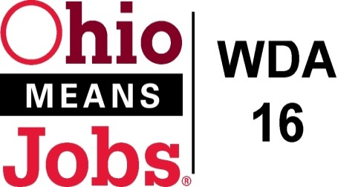
WDA 16

A proud partner of the
American Job Center network

Policy Letter 01-2016
Policy: Standardized Supportive Service Policy

PURPOSE

To establish a standardized supportive service policy for adults, youth and dislocated workers enrolled in Title I activities under the Workforce Innovation Opportunity Act (WIOA) and under the Ohio Comprehensive Case Management and Employment Program (CCMEP).

- WORKFORCE DEVELOPMENT BOARD APPROVAL

Motion 28-2016 approved on Nov 18, 2016.

- POLICY CANCELLATION

Policy Letter 09-2015 approved November 20, 2015.

- POLICY LETTER IMPLEMENTATION

Supportive services are services, such as transportation, child care, dependent care, housing, and needs-related payments, that are necessary to enable an individual to participate in career and training services. Referral to supportive services is one of the career services that must be made available to adults and dislocated workers through the workforce development system.

Supportive services may only be provided to participants who are in career or trainings services, unable to obtain supportive services through other programs providing supportive services, and that they must be provided in a manner necessary to enable individuals to participate in career and/or training services.

IV. REQUIREMENTS

- Referral process

WDB-16, in consultation with the OhioMeansJobs partners and other community service providers, in the counties will refer individuals to others programs for services as identified. A denial letter is only required to be considered for WIOA/CCMEP supportive service(s) where the support service(s) may already be available in the county.

- Supportive Services Provided

Our Workforce Development Area may provide the following supportive services based on the need and situation of the individual including:

Mileage stipend for transportation; Payment/reimbursement for child care/dependent care; Meal payment/reimbursement for out-of-the area training; Lodging assistance for out-of-the area training; and Financial assistance for the purchase of uniforms or other appropriate work attire and work-related tools, including such items as eye glasses and protective gear, as required for activity. Supportive services when being provided for other than a training activity are available only to remove barriers to obtain full time, self-sufficient employment. Other supportive services (such as parking fees) allowable under the WIOA may be provided with the approval of the Program Operator.

In addition, CCMEP can provide for the same above services for eligible youth and also can provide for auto repair/tires, to address transportation as a barrier to employment or on-the-job training.

- Level of Supportive Services

Level of supportive services will be in accordance with the policies approved by the local Workforce Development Board.
(See Attachment A).

It should be noted that the funding amounts are the maximum amounts authorized, and that the Program Operators can pay less for these supportive services, but they may not exceed these amounts.

V. Reporting Requirements

Pursuant to rule 5101:9-30-04 of the Administrative Code, the local board shall ensure the timely and accurate reporting of WIOA and CCMEP participants, activities, and performance information by using the Ohio Workforce Case Management System (OWCMS) and the County Finance and Information System (CFIS).

VI. Requirements Monitoring

At the local level, the local area must conduct oversight of the implementation of the WIOA and CCMEP programs to ensure that participants are enrolled in the programs and have been provided identified services.

END

