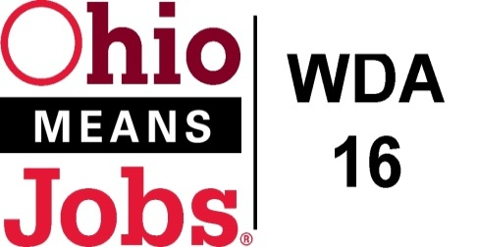
WDA 16

A proud partner of the
American Job Center network

Policy Letter 01-2015
Policy: Policy Letter Procedures
PURPOSE
To develop Workforce Innovation Opportunity Act (WIOA) operational policy and procedures for Workforce Development Area 16 (WDB-16) that are in compliance with rules and regulations under the WIOA, as well as all applicable local, state and federal laws.

- WORKFORCE DEVELOPMENT BOARD APPROVAL
Motion 28-2015 approved on August 28, 2015.

- POLICY CANCELLATION

Policy Letter 01-2004 approved July 29, 2004

- PROCEDURES FOR POLICY REVIEW, APPROVAL AND IMPLEMENTATION

As necessary, policies will be drafted by a committee comprised of the areas Workforce Development Agencies and/or Subcontractors as appropriate. These policies will be sent in draft format to the WDB-16 for review and eventual approval.

- STORAGE AND RETENTION
All policies are sequentially numbered by year, upon approval by WDB. Policies will be maintained by the staff of the WDB with copies provided to respective County Workforce Development agencies and applicable subcontractors.

- REQUIREMENTS
All requirements mandated by WIOA, and all other applicable Local, State and Federal requirements as they apply to the WIOA will be met. Additional added requirements may be added at the discretion of the WDB.

- DURATION
An approved policy is in effect until superseded by a revision or repealed by the WDB.

END

