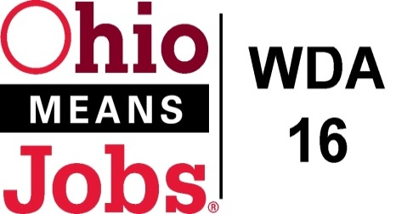
WDA 16

A proud partner of the
American Job Center network

Policy Letter 01-2019
Policy: Youth Incentives

PURPOSE

The purpose of this policy is to provide Incentives to Workforce Innovation and Opportunity Act (WIOA) and Comprehensive Case Management and Employment Program (CCMEP) eligible youth that encourages and motivates these youth to attain specific program goals and positive outcomes while enrolled in training, educational, and work experience activities.

- WORKFORCE DEVELOPMENT BOARD APPROVAL

Motion 19-2019 approved on May 31, 2019
This replaces Motion 25-2017 approved June 23, 2017 (PL 02-2010)

- BACKGROUND

Per Workforce Investment and Opportunity Act (WIOA), regulations at 20CFR part 681.640, incentives are an allowable service that can be provided to WIOA eligible youth for recognition and achievement directly tied to training, education, and work experiences. CCMEP youth participants are also eligible for these performance based incentives. CCMEP Youth participants funded under the TANF program are also potentially eligible for these performance incentives, in accordance with the incentive policy of the lead agency that is carrying out the TANF services in a county.

- IMPLEMENTATION

Incentives are not an entitlement. Incentives will be provided to the youth at the discretion of the Program Operator and are subject to available funding.

Incentives may only be cash payments (payable by check). The maximum payment to a youth for attaining one (1) program goal. Or positive outcome, is $100.00. During a Program Year (July 1-June 30), total incentive payments to a youth cannot exceed $1,000.00.

Payment of incentives must be connected to the goals and objectives stated in the youth’s Individual Opportunity Plan (IOP).

Incentives may be issued to youth for attaining goals and positive outcomes including, but not limited to the following:

- Primary or Secondary School grade level advancement or GED Progress: $50.00 for each grade advancement from 1st grade to 10th grade level, $100 for each grade advance from 10th grade to 12th grade level.
- Attainment of high school diploma/GED: $100.00.
- Successful completion of each educational/academic Credit Recover Course: $50.00.
- Successful completion of a Nationally Recognized Certification or Licensure program, or degree: $100.00
- Obtaining a Nationally Recognized Certification or License: $100.00.
- Successful completion of work experience, as determined by the Program Operator: $100.00
- Other training, educational, and work experience activities as approved by the Program Operator, consistent with 20CFR 681.640: $50 or $100.

Documentation must be maintained by the Program Operator or Subcontractor and include at a minimum:

- Documentation of the Goal/Positive Outcome to be attained in the IOP
- Documentation of evidence of goal attainment
- Documentation that the Incentive was issued to the Youth

END

