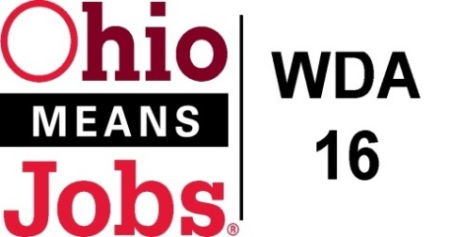
WDA 16

A proud partner of the
American Job Center network

Staff to the Board Report 7/1/20 Rob Guentter
Virtual Fairs: A Virtual Fair program is already being used in Franklin Co with good success. This will be something to pay attention to as the state research advances. JobsOhio OhioSE looking into purchasing a program for the region.
TEAM update: Tri State Energy and Advanced Manufacturing (TEAM) Consortium has developed a new web site to promote careers, training options, and employment opportunities. Visit www.connect2team.org
In addition, TEAM has submitted a 2020 ARC Power Grant to serve the tri-state area (OH, WV, and PA). The grant proposal includes $308,500 for each of the 9 WDAs in the consortium (including WDA16). These funds, over 2 years, would cover (1) Career Specialist ($120,000), 10 $3,000 scholarships ($30,000), $50,000 in outreach, T/A and resources/Adult learners and student success $48,000, and data collection and analysis $60,000. These resources- would benefit education partners and the WDA. TEAM is also working on a $1.5m WORC Rural Workforce DOL grant. FYI, I believe our area CACs are also working on submitting for this same funding.

WDA16 WIOA Performance: The state has indicated that we will not be negotiating the next 2 years of required WIOA Title 1 standards until August/Sept. 2020. As our performance period starts 7/1/20, it will likely be 6 months into performance before we know what we are supposed to be achieving.

Incumbent Worker Training (IWT) Local draft Policy: The state is working on clearer guidelines for areas to complete or revise their IWT policies. They are also talking about funding IWT programs in areas with compliant policies. As soon as the new guidance is released WDA16 needs to complete our ITW policy.

Business Outreach: We are still working with our Operators to develop a policy that uses WDA resources wisely and actually helps local employers, all within WIOA regulations. The state has issued clearer guidelines for business outreach efforts.

WDB16 Board Recertification: Every 2 years the WDB16 Board needs to be recertified by the State I do not fore see any problems getting this done by the August 2020 deadline.

Local and Regional Workforce Plan: The state is requiring our Local and Regional Workforce Plan (WDAs 14,15 and 16) to be redone by March 31, 2021.

Outreach Data: A data chart is attached showing the hits on our social media web platforms. This is based on the work conducted by Mobilize360.

SCSEP MOUs with Goodwill: Goodwill Industries of both Zanesville and Central Ohio/Cleveland are competing to secure federal funds to serve WDA16 with the Senior Community Service Employment Program. We have signed MOUs with both. Services will not be duplicated if they are awarded, as this is a master Goodwill USA application.

ApprenticeOhio: The WDB16 is studying becoming an Apprenticeship Sponsor for the area. This would allow businesses to set up apprenticeships with a lot less paperwork and allow for pre apprenticeship programs with area high schools.

