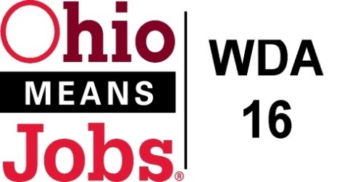 COG Meeting
WDA 16

A proud partner of the
American Job Center network

July 17, 2020
10:00 AM
GoToMeeting
Call to Order
COG WDA16 Friday July 17, 2020 10am-12:00 PM (EDT)

Please join my meeting from your computer, tablet or smartphone.

https://global.gotomeeting.com/join/275866493

You can also dial in using your phone.
(For supported devices, tap a one-touch number below to join instantly.)

United States: +1 (646) 749-3122
- One-touch: tel:+16467493122,,275866493#
Access Code: 275-866-493

New to GoToMeeting? Get the app now and be ready when your first meeting starts: https://global.gotomeeting.com/install/275866493

- Roll Call:
- Approval of Minutes (5/5/20)

- Financial/Participants Reports (Rob and Rebecca)
- Financial Report (_______ 2020).
- Allocation vs Expense Report
- 2020 WDB16 Administrative Budget
- Transfers: $5,165 COVID Extra allocation to Harrison Co., as recommended by WDB16 Motion 03-2020

- WIOA Update: Staff Report
- Virtual Fairs
- TEAM updates: website and ARC Power Grant
- WDA16 Performance Measures 2020
- Incumbent Worker Training (IWT)
- Business Outreach Policy
- WDB16 Board Recertification
- Local and Regional Workforce Plan (new 3/31/21 due date)
- Outreach Data
- ApprenticeOhio

- OMJ Operations Reports

- Addendum 2 to RFG Associates Inc. Flood Inspection Services 7/1/20-11/30/20 $3,250 ($650/month)
as recommended by WDB16 Motion 05-2020
- Ohio Workforce Association (OWA) 20-21 Dues $4,018.00, as recommended by WDB16 Motion 06-2020
- Grants to Accept:
a) Business Outreach (Rapid Response funding) $160,000, as recommended by WDB16 Motion 07-2020
b) COVID19 Employment Recovery National DW Grant $62,000, as recommended by WDB16 Motion 08-2020

- Additional Discussions
Next Meetings – September 2020 Time and Location TBD

11. Adjournment

