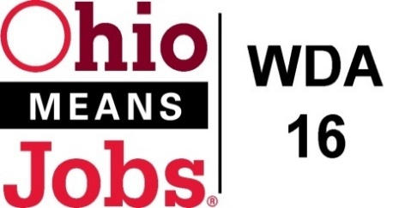 WDB16 Board Meeting
WDA 16

A proud partner of the
American Job Center network

September 18, 2020
10:00 AM
GoToMeeting
- Call to Order
WDB16 Board Meeting
Fri, Sep 18, 2020 10:00 AM - 12:00 PM (EDT)

Please join my meeting from your computer, tablet or smartphone.

https://global.gotomeeting.com/join/645210285

You can also dial in using your phone.
(For supported devices, tap a one-touch number below to join instantly.)

United States: +1 (872) 240-3311
- One-touch: tel:+18722403311,,645210285#

Access Code: 645-210-285

New to GoToMeeting? Get the app now and be ready when your first meeting starts: https://global.gotomeeting.com/install/645210285

- Roll Call
- Approval of Minutes (06/26/2020)
- New Board Member: Ed Mowrer introduction
- BRN: Bradley Wells introduction
- Financial/Participants Reports (Rob and Rebecca)
- Financial Report (August 2020).
- Allocation vs Expense Report
- Transfers:

- WIOA Update: Staff Report
- Virtual Fairs
- BRN Business Outreach
- WDA16 Performance Measures 2020
- Incumbent Worker Training (IWT)
- Business Outreach Policy
- WDB16 Board Recertification
- Local and Regional Workforce Plan revision
- New Outreach Video
- Pathways Home

- Coronavirus and OMJ operations
- Resource Room updates
- MOU revision
- ApprenticeOhio Sponsorship
- Ohio Data Share Agreement
- Individual Training Account (ITA) policy revision
- Incumbent Worker Training (IWT) policy revision
- Additional Discussions

- Next Meetings – Fri December 4, 2020 Location TBD 15. Adjournment

