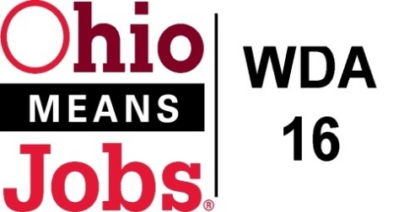
WDA 16

A proud partner of the
American Job Center network

Staff to the Board Report 9/18/20 Rob Guentter
Virtual Fairs: The state has selected Brazen as the platform for virtual job fairs. WDA 16 has been awarded 1 virtual job fair. We are looking at the week after Easter. We can purchase more if needed.
BRN Business Outreach: A Board appointed committee has selected Bradly Wells to serve as our 1-year Business Resource Network (BRN) Outreach Exec. Bradley will work out of the Jefferson Co CAC office, with his work product coordinated with Rob. He will be tasked with working on our Virtual Job Fair project, Apprenticeship development, general business outreach to connect to our OM Centers, sector strategy advancement, and helping with our revised Local and Regional Workforce Plan. His contract runs from Sept 1, 2020 to June 30, 2021. Thanks to Tammy, Ed, Rich and Alison for your help with this selection process.
WDA16 WIOA Performance: The state has issued recommended WDA16 WIOA Performance standards for WDA16. The operators have agreed to accept these standards as presented by the state. A copy is attached

Incumbent Worker Training (IWT) Policy: Ready for Board consideration

Business Outreach: We are still working with our Operators to develop a policy that uses WDA resources wisely and actually helps local employers, all within WIOA regulations. The state has issued clearer guidelines for business outreach efforts. We need to hold a WDB16 Board Outreach Committee meeting with the Operators to finalize our local plan of action

WDB16 Board Recertification: Every 2 years the WDB16 Board needs to be recertified by the State. I am waiting for a few documents to submit our full Recertification package.

Local and Regional Workforce Plan: The state is requiring our Local and Regional Workforce Plan (WDAs 14,15 and 16) to be redone by March 2021. The Directors in WDA 14, 15 and 16 have developed an outline for us to” divide and conquer” and to complete this project in house. Board members will be receiving a surrey to complete before the end of the year.

New Outreach Video: Mobilize360 has completed a new 30 second video for use in social media and TV/radio outreach. The video follows our “Opportunity Knocks” theme and informs job seekers that when they feel safe and are ready to go back to work, we are here to help them.

Pathways Home: WDA16 has been included in the state Pathways Home initiative to help incarcerated persons successfully address barriers to renter into our communities and workforce. Based out of the Belmont Co OMJ Center, our state subcontracted Reentry Navigator will work primarily with Belmont and Noble Corrections populations. This is a 3-year effort set to begin in September/October 2020. Our MOU revision will reflect this project.

