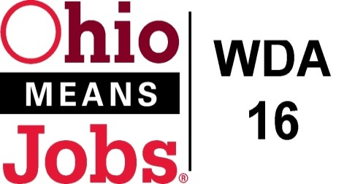
WDA 16

A proud partner of the
American Job Center network

COG Meeting
GoToMeeting
10/1/2020 10am
COG Meeting WDA16
Thu, Oct 1, 2020 10:00 AM - 12:00 PM (EDT)
Please join my meeting from your computer, tablet or smartphone.
https://global.gotomeeting.com/join/671286269
You can also dial in using your phone.
(For supported devices, tap a one-touch number below to join instantly.)
United States: +1 (872) 240-3212
- One-touch: tel:+18722403212,,671286269#
Access Code: 671-286-269
New to GoToMeeting? Get the app now and be ready when your first meeting starts: https://global.gotomeeting.com/install/671286269

- Roll Call
- Approval of Minutes (01/17/2020)
- BRN: Bradley Wells introduction
- Financial/Participants Reports (Rob and Rebecca)
- Financial Report August 2020).
- Allocation vs Expense Report
- Transfers:

- WIOA Update: Staff Report
- Virtual Fairs
- BRN Business Outreach
- WDA16 Performance Measures 2020-21
- WDB16 Board Recertification
- Local and Regional Workforce Plan revision
- New Outreach Video
- Pathways Home

- Coronavirus and OMJ operations
- Resource Room updates

- MOU revision

- ApprenticeOhio Sponsorship

- Ohio Data Share Agreement

- Additional Discussions

- Next Meetings – Fri December 4, 2020 Location TBD

- Adjournment

