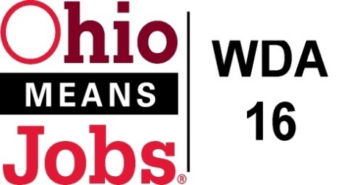
WDA 16

A proud partner of the
American Job Center network

Staff to the Board Report 12/4/20 Rob Guentter
Virtual Job Fairs: The state has selected Brazen as the platform for virtual job fairs. WDA 16 has been awarded 1 virtual job fair which we will use in April 2021. Additionally, using our BRN grant, we have Premier Virtual for 1 year for additional job fairs. We are looking to stage a Warehouse/Distribution virtual job fair in January 2021.
BRN Business Outreach: Bradly Wells, Business Resource Network (BRN) Outreach Exec. Has been busy working on the Virtual Job Fair project, Apprenticeship development, and general business outreach to connect to our OM Centers.
WDA16 WIOA Performance: The state has issued recommended WDA16 WIOA Performance standards for WDA16. The operators have agreed to accept these standards as presented by the state. A copy is attached.

WDB16 Board Recertification: The WDB16 Board recertified package has been submitted and accepted by the state. We are good for two (2) more years!

Local and Regional Workforce Plan: The state is requiring our Local and Regional Workforce Plan (WDAs 14,15 and 16) to be redone by March 2021. Work is moving forward on this plan, with an assessment of what we have accomplished, and yet to accomplish from our prior plan, almost completed.

Incumbent Worker Training Policy (IWT): While we are now permitted to spend WIOA funds on incumbent worker training, the current draft policy is linked to needs in our under review Local and Regional Workforce Plan. As the new Plan must be done by March 2021, we are recommending pausing the completion of the IWT Policy so that we can align IWT with the revised Workforce Plan.

Pathways Home: WDA16 has been included in the state Pathways Home initiative to help incarcerated persons successfully address barriers to renter into our communities and workforce. While we were initially going to house the person at the Belmont OMJ, the state has taken a new course based on federal feedback to the project, and are centralizing employment at a few hubs in Ohio. The Belmont Co MOU has been revised to reflect this change.

