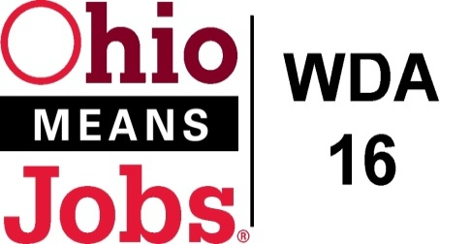
WDA 16

A proud partner of the
American Job Center network

COG Meeting Fri Dec 11, 2020 10am
Fri, Dec 11, 2020 10:00 AM - 12:00 PM (EST)

Please join my meeting from your computer, tablet or smartphone.

https://global.gotomeeting.com/join/432458373

You can also dial in using your phone.
(For supported devices, tap a one-touch number below to join instantly.)

United States: +1 (786) 535-3211
- One-touch: tel:+17865353211,,432458373#
Access Code: 432-458-373

New to GoToMeeting? Get the app now and be ready when your first meeting starts: https://global.gotomeeting.com/install/432458373

- Roll Call

- Approval of Minutes (07/17/20)

- Financial/Participants Reports (Rob and Rebecca)
- Financial Report (Oct 2020).
- Allocation vs Expense Report
- Transfers:

- COG Board Leadership
Chair
Vice-Chair

- WIOA Update: Staff Report
- Virtual Job Fairs
- BRN Business Outreach
- WDA16 WIOA Performance Standards
- WDB16 Board Recertification-submitted and accepted by State
- Local and Regional Workforce Plan update
- Incumbent Worker Training Policy (IWT)
- Pathways Home update

- OMJ Operations Reports
- Resource Room updates

- RESEA Sub-Contract with Jefferson Co CAC

- RFG Associates Inc Amendment #3 OH32 Flood Inspections 12/1/20 to 6/30/21

- MOU Revision

- Ohio Data Share Agreement

- ApprenticeOhio Sponsorship

- Sub-grant Agreements between WDB16 and each County update

- 2021 COG Proposed Meeting Schedule: Friday March 26, 2021 10am GoToMeeting
Friday June 25, 2021 10am GoToMeeting
Friday September 24, 2021 TBD
Friday December 17, 2021 TBD

- Additional Discussions

- Next Meetings – Friday March 26, 2021 10am GoToMeeting

- Adjournment

