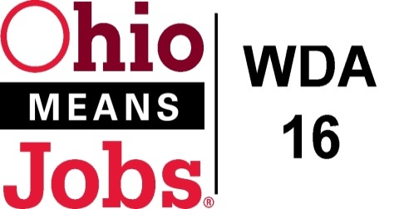
WDA 16

A proud partner of the
American Job Center network

Year 2 MOU Revision WD16
7/1/ 2020 to 6/30/2021
While the WDB16 MOU covers al four (4) WDA16 counties, only Belmont Co requires new partner signatures due to partner changes and cost adjustments since Year 1.

Belmont Co Partner | 2019-2020 Partner Share (Year 1) | 2020-2021 Partner Share  (Year 2) | Change
ODJFS | $74,527 | $78,242 | + $3,715
WIOA | $79,098 | $83,187 | + $4,089
TANF | $8,862 | $9,313 | + $451
ASPIRE (EGCC) | $3,251 | $3,398 | + $147
OOD | $20,702 | $21,734 | + $1,032
Older Americans  (Good Will) | $3,251 | $3,398 | + $147
CCMEP  (Belmont CAC) | $20,702 | $21,734 | + $1,032
Perkins (Belmont College) | $3,251 | $3,398 | + $147
All State Career Center (CDL) | $7,698 | $8,142 | + $444
Total | $221,342 | $232,545 | + $11,203

