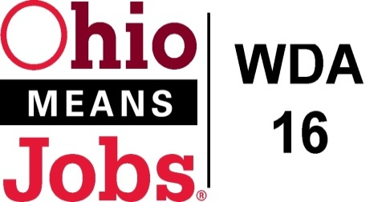
WDA 16

A proud partner of the
American Job Center network

Ohio Freedom of Information Act
Request for Information

Date of Request: ___________________________________
Requester’s Name: (Optional) ___________________________________
Requester’s Address: __________________________________________
____________________________________________________________
Requester’s Email: ____________________________________________

Phone (Optional): __________________________________
Organization (Optional): _____________________________

Under the Freedom of Information Act, we are requesting the following information from Workforce Development Board 16 (WDB16):
______________________________________________________________________________________________________________________________________________________________________________________________________________________________________________________________________________________________________________________________________________________________________________________________________________________________________________________________________________________________________________________________________________________________________________________________________________________________________________________________________________________________________________
(Add additional pages if necessary)

Please return this request to: Rob Guentter, Staff to the WDB16 Board (Custodian of Records)
PO Box 2112
Zanesville, OH 43702-2112
Or email to: rob@rfgassociates.net

Date received by WDB16: __________________________ Date of Response: _________________________________
Information sent: ___________________________________________________________________________________
Confirnmation material was received: __________________________________________________________________

