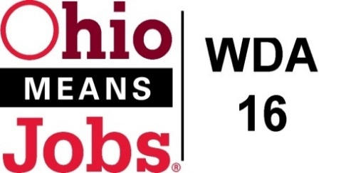
WDA 16

A proud partner of the
American Job Center network

WDB16 Board Meeting
March 19, 2021
10:00 AM
GoToMeeting
- Call to Order

WDB16 Board Meeting
Fri, Mar 19, 2021 10:00 AM - 12:00 PM (EDT)

Please join my meeting from your computer, tablet or smartphone.

https://global.gotomeeting.com/join/575378053

You can also dial in using your phone.
(For supported devices, tap a one-touch number below to join instantly.)

United States: +1 (571) 317-3122
- One-touch: tel:+15713173122,,575378053#

Access Code: 575-378-053

New to GoToMeeting? Get the app now and be ready when your first meeting starts: https://global.gotomeeting.com/install/575378053

- Roll Call

- Approval of Minutes (12/4/20)

- Financial/Participants Reports (Rob and Rebecca)
- Financial Report (Feb 2021).
- Allocation vs Expense Report
- WDA16 Audit

- Transfers:

- WDB16 Board Leadership
Vice-Chair

- WIOA Update: Staff Report
- Virtual Job Fairs
- RESEA update
- Local and Regional Workforce Plan update
- Data Share Agreement approved
- Area Performance
- OMJ.com updates

- OMJ Operations Reports

- Operator RFP, approval to bid/ timeline

- MOU Extension 7/1/21 to 6/30/22

- County Sub grant Agreements 7/1/21 to 6/30/23

- Additional Discussions

- Next Meetings – Friday May 21, 2021 10am GoToMeeting
Future Meetings: Fri June 18, 2021 if needed 10am GoToMeeting
Fri Sept 17, 2021 10am TBD
Fri Dec 10, 2021 10am TBD

- Adjournment

