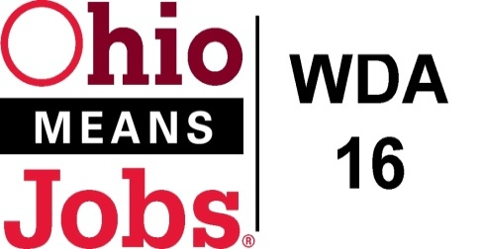
WDA 16

A proud partner of the
American Job Center network

Section 2: PROCUREMENT PROCESS

RFP Timeline

Date | Event/Activity | Comment
March 22, 2021 | Release of RFP
March 31, 2021 | Pre-Bidder Conference | GoToMeeting
April 23, 2021 | RFP Due Date | By Noon, electronic submissions only
Completed by May 19, 2021 | Review Period | WDB16 Executive Board
By May 28, 2021 | WDB16 and COG approvals
June 1, 2021 | Award Announcement
June 2, 2021 to June 9, 2021 | Protest Period
June 10, 2021 | Contract Awarded
June 10, 2021 -June 25, 2021 | MOU Completion | Coordinate completion of MOU with WDB16 Staff
July 1, 2021 to June 30, 2022 | Contract Period (one (1) year)
Discussion begins Jan. 2023 | Contract Renewal Option | 1- or 2-year contract extension as per WDB16

RFP submission detail is provided in Section 5: RFP Submission Instructions.

☞ Deadline date and time: April 23, 2021 at noon EST. electronic submission only

☞ To: rob@rfgassociates.net

