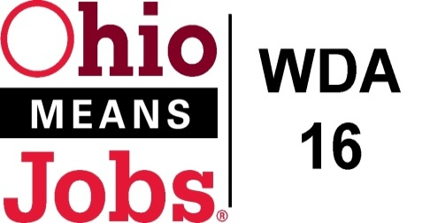
WDA 16

A proud partner of the
American Job Center network

Responses to Q and A from 3/31/21 OMJ WDA16 Operators Bidding Conference

Question 1: If multiple organizations are involved in the proposal, whose bylaws /article of incorporation need to be submitted?
Response: Only the lead agency, who will serve as the administrative contact for the services needs to include their documents.

Question 2: Is there a page limit for the proposal?
Response: The RFP does not identify a page limit for the proposals. WDB16 recommends keeping your formal responses to under 25 pages alone with up to an additional 10 pages for supportive material you believe adds value to your proposal.

Question 3: How many years should we show for the submitted budget?
Response: Please provide a 2-year budget on the provided budget format in the RFP.

End of questions.

