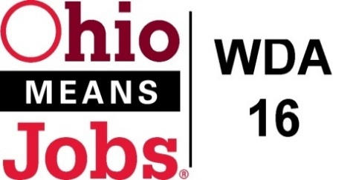
WDA 16

A proud partner of the
American Job Center network

WDB16 Board Meeting
May 21, 2021
10:00 AM
GoToMeeting
- Call to Order

WDB16 Board Meeting 5/21/21 10am
Fri, May 21, 2021 10:00 AM - 12:00 PM (EDT)

Please join my meeting from your computer, tablet or smartphone.

https://global.gotomeeting.com/join/711766413

You can also dial in using your phone.
(For supported devices, tap a one-touch number below to join instantly.)

United States: +1 (786) 535-3211
- One-touch: tel:+17865353211,,711766413#

Access Code: 711-766-413

New to GoToMeeting? Get the app now and be ready when your first meeting starts: https://global.gotomeeting.com/install/711766413

- Roll Call

- Approval of Minutes (3/19/21)

- Financial/Participants Reports (Rob and Rebecca)
- Financial Report (May 2021).
- Allocation vs Expense Report

- Transfers:

- WDB16 Board Leadership
Vice-Chair

- WIOA Update: Staff Report
- Virtual Job Fairs
- RESEA update
- Environmental Scan for Youth Elements
- Ohio Workforce Association (OWA) update
- Local and Regional Workforce Plan
- WDB16 Board Members 2-year terms
- State Subgrant Agreement with WDA16

- OMJ Operations Reports

- OMJ Operator RFP, Contract Recommendation for Approval Item 4 on Contract Matrix)

- Vendor Contracts for Renewal (See matrix)
Item 2 Mobilize360 outreach, Item 3 Staff to the Board, Items 5-6 Adult and DW Framework and Design, Items 13-14 Youth Design and Framework, Items 15-20 Belmont Youth Elements, Items 21-24 Carroll Co Youth Elements, Items 25-27 Harrison Co Youth Elements, Items 28-30 Jefferson Co Youth Elements, Item 32 Opioid 3 extended monitoring, and Item 33 CCMEP Youth Transportation with SEAT

- CORSA Insurance Invoice $2,895.00 5/1/21 to 5/1/22

- Ohio Workforce Association (OWA) 2021 Dues $4,018.00

- BRN Special Project WIOA Grant Submission

- Belmont Co Library MOUs (Belaire, Belmont Co., Barnesville, St Clairsville) 7/1/21 to 6/30/23

- State Sub-Grant Agreement 7/1/21 to 6/30/23

- Southeast Ohio Local and Regional Workforce Plan (2021-2025)

- Additional Discussions

- Next Meetings – 10am GoToMeeting
Future Meetings: Fri June 18, 2021 if needed 10am GoToMeeting
Fri Sept 17, 2021 10am TBD
Fri Dec 10, 2021 10am TBD

- Adjournment

