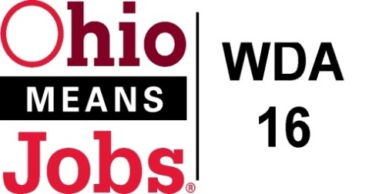
WDA 16

A proud partner of the
American Job Center network

Staff to the Board Report 5/21/21 Rob Guentter

Virtual Job Fairs: Our second Virtual Job Fair was held on April 29, 2021. The attached sheet summarizes the numbers for the day. Our next VJF is being planned. Our goal is approximately 1 event per month. Much thanks to Bradley Wells, Neil Polk and Dan Wilson for making these happen.
RESEA update: Jefferson Co CAC is successfully managing the transition of RESEA services from the state to the local area.
Environmental Scan for Youth Elements: Next year we will need to bid out all of the Youth Element service contracts. As things change over the years, I will be working with the Operators to conduct an environmental scan to help determine which of the 14 WIOA Youth Elements are most needed in each county. This scan will work to evaluate who is currently offering any of the 14 youth elements, and if these service levels are meeting actual needs. This effort should help inform us as to which elements need to be bid out to fill critical service gaps.
Ohio Workforce Association (OWA): OWA is the state workforce organization comprised of all 20 workforce area directors in Ohio. Our group has made great strides the past number of years and we now have greater access and influence on state policy and operational decision making. We are also making inroads with legislators. The group is looking to hire a full-time Executive Director to guide this work moving forward. For the past 1 1/2 years, I have served as an elected member of the OWA Executive Committee as now as a member of the Executive Director search team.
Local and Regional Workforce Plan: The draft Local and Regional Workforce Plan (2021-2025) was completed on April 28, 2021, advertised in local papers, and posted on all 3 area web sites for 30-day comment period to May 29, 2021. The plan covers all 11 counties in Areas 14, 15 and 16.

WDB16 Board member 2-year terms: All WDB16 Board members serve 2-year terms. These current terms expire 6/30/21. I have communicated with Commissioners in all 4 of our counites and have requested that they reappoint each of the current Board members for a new 2-year term from 7/1/21 to 6/30/23. If you are unable to continue serving, please reach out to me, your local JFS Director, or your County Commissioners. I sincerely hope each of you decide to stay on and are reappointed, at the full discretion of our County Commissioners.

State Subgrant Agreement with WDA16: We are still waiting to receive our new agreement which will cover 7/1/2021 to 6/30/2023.

