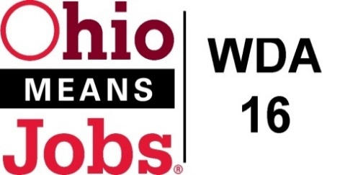
WDA 16

A proud partner of the
American Job Center network

WDB16 Board Meeting
September 17, 2021
10:00 AM
GoToMeeting
- Call to Order

WDB16 Board Meeting
Fri, Sep 17, 2021 10:00 PM - 12:00 AM (EDT)

Please join my meeting from your computer, tablet or smartphone.

https://global.gotomeeting.com/join/619487165

You can also dial in using your phone.
(For supported devices, tap a one-touch number below to join instantly.)

United States: +1 (571) 317-3112
- One-touch: tel:+15713173112,,619487165#

Access Code: 619-487-165

New to GoToMeeting? Get the app now and be ready when your first meeting starts: https://global.gotomeeting.com/install/619487165

- Roll Call
- Welcome NEW Board Members: Jeff Vaughn, Mark Trew, Dean Petersen
- Recognize departing Board Members: Ed Mowrer, Alison Kerns, Tait Carter

- Approval of Minutes (5/21/21)

- Financial/Participants Reports (Rob and Rebecca)
- Financial Report (August 2021).
- Allocation vs Expense Report

- Transfers:

- WDB16 Board Leadership
Vice-Chair election

- WIOA Update: Staff Report
- Virtual and In person Job Fairs
- RESEA update
- Environmental Scan for Youth Elements
- Local and Regional Workforce Plan-approved
- Apprenticeship Update
- BRN update

- OMJ Operations Reports

- BRN Special Project WIOA Grant Submission $111,061

- New Beginnings Jefferson CAC Special Projects Grant Request $108,030

- LPL 21-01 Youth Incentives Policy

- LPL 21-02 Virtual Meetings Policy

- LPL 21-03 Self Sufficiency

- State Data Share Agreement 10/1/21 to 9/30/23
( new RESEA, Wage Record Data, Employer UI Trend data (as state moves from WCMS to Aries)

- Additional Discussions

- Next Meetings – Fri Dec 10, 2021 10am GoToMeeting
Future Meetings: 2022 meeting schedule will be presented at 12/10/21 meeting

- Adjournment

