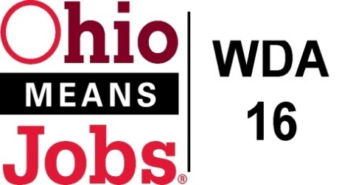
WDA 16

A proud partner of the
American Job Center network

Staff to the Board Report 9/17/21 Rob Guentter

Virtual and In Person Job Fairs: Both Belmont (8/26/21) and Jefferson Co (9/22/21) have held/planned in person job fairs and we have held numerous virtual job fairs since May 2021. The Premier Virtual software contract has been extended 2 years for on going efforts, using funding we would have lapsed back to Ohio.
RESEA update: Jefferson Co CAC continues to successfully managing the transition of RESEA services from the state to the local area. We appear to have enough state funding to get to March 2022 and the state is in the process of awarding additional funding as needed.
Environmental Scan for Youth Elements: Next year we will need to bid out all of the Youth Element service contracts. As things change over the years, I will be working with the Operators to conduct an environmental scan to help determine which of the 14 WIOA Youth Elements are most needed in each county. This scan will work to evaluate who is currently offering any of the 14 youth elements, and if these service levels are meeting actual needs. This work can be used for the required CCMEP Plan update and to inform our WDB16 RFP bidding for Youth Services next year. We are looking to have the RFP our in February 2022 for award/implementation in July 2022. This means the Board will be reviewing summited proposals in late April and May 2022
Local and Regional Workforce Plan: The Local and Regional Workforce Plan (2021-2025) has been approved by the state and posted on www.OMJ16.com. WDA16 is participating in regional training (areas 14, 15 and 16) for Ohioans with Disabilities Etiquette on Sept 23, 2021. This training will help us with our OMJ Center recertification which will be due in June 2022.

Apprenticeship Updates:
We are working with Belmont College and a number of Belmont Co schools to help support STNA training for high school students. We are also looking at coordinating this effort with local nursing homes and encouraging participating youth to continue their healthcare training pathway into apprenticeship qualifying programs. There is a greater willingness for local schools to participate now that Ohio Graduation Seals are being required.

BRN update: The state has announced a new round of BRN funding and we are looking to apply for 1 additional year with the same job fair, apprenticeship and business engagement focus we are currently implementing.

