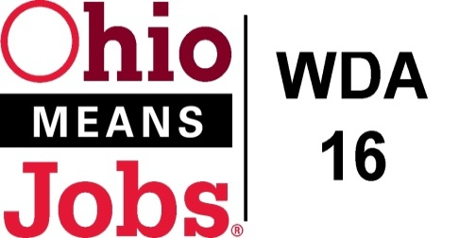
WDA 16

A proud partner of the
American Job Center network

COG Meeting
September 24, 2021 10:00 AM
In person at the Harrison Co JSF Office, 520 N Main Street Cadiz , OH

- Call to Order

- Roll Call

- Approval of Minutes (5/28/21)

- Financial/Participants Reports (Rob and Rebecca)
- Financial Report (August 2021).
- Allocation vs Expense Report
- Transfers:

- WIOA Update: Staff Report
- Virtual and In person Job Fairs
- RESEA update
- Environmental Scan for Youth Elements
- Local and Regional Workforce Plan-approved
- Apprenticeship update
- BRN update

- OMJ Operations Reports

- BRN Special Project WIOA Grant Submission $111,061

- New Beginnings Jefferson CAC Special Projects Grant Request $108,030

- State Data Share Agreement 10/1/21 to 9/30/23
(New RESEA, Wage Record Data, and Employer UI Trend data)

- Additional Discussions

- Next Meetings – Fri Dec 17, 2021 10am
Future Meetings: 2022 meeting schedule will be presented at 12/17/21 meeting

- Adjournment

