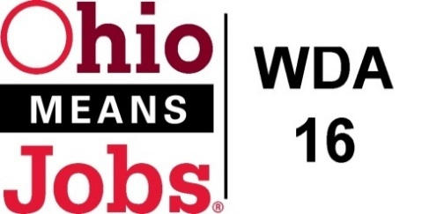
WDA 16

A proud partner of the
American Job Center network

WDB16 Board Meeting
December 10, 2021
10:00 AM
GoToMeeting
- Call to Order

WDB16 Board Meeting
Fri, Dec 10, 2021 10:00 AM - 12:00 PM (EST)
Please join my meeting from your computer, tablet or smartphone.
https://global.gotomeeting.com/join/573543213
You can also dial in using your phone.
United States: +1 (312) 757-3121
Access Code: 573-543-213

- Roll Call

- Approval of Minutes (9/17/21)

- Financial/Participants Reports (Rob and Rebecca)
- Financial Report (October 2021).
- Allocation vs Expense Report

- Transfers:
BRN Mod #2 Use of WIOA Admin for BRN from 11/20/21 to 12/31/21 $12,500

- WIOA Update: Staff Report
- Environmental Scan for Youth Elements
- Apprenticeship Update
- New Beginnings Special Grant awarded $92,976.71
- WDA OMJ Recertification due June 2022
- Burr Oak Career Conference Oct 27, 2021
- OWA Director position
- State Survey-Mckinsey and Co.
- Transfr VR

- OMJ Operations Reports

- BRN Special Project WIOA Grant Submission $167,879.35
(1/1/22 to 6/30/23)
- New Beginnings Jefferson CAC Special Projects Grant Administration

- LPL 21-04 Individual Training Accounts (ITAs)

- LPL 21-05 Incumbent Worker Training (IWT)

- Approval to bid Youth Elements (All counites), Adult and Dislocated Workers
(Jefferson and Harrison Cos), and Framework/Design (Jefferson and Harrison Cos)
RFP schedule

- Additional Discussions

14. Next Meetings – Fri March 11, 2022 10am GoToMeeting
Future Meetings:

Fri March 11, 2022 Fri June 3, 2022 Fri Sept 9, 2022 Fri December 9, 2022

15. Adjournment

