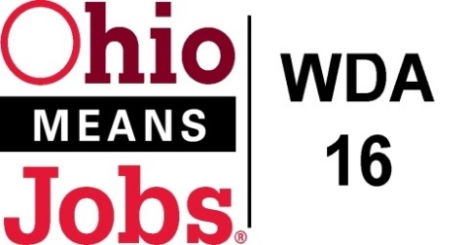
WDA 16

A proud partner of the
American Job Center network

Staff to the Board Report 12/10/21 Rob Guentter

Environmental Scan for Youth Elements: Next year we will need to bid out all of the Youth Element service contracts. As things change over the years, I will be working with the Operators to conduct an environmental scan to help determine which of the 14 WIOA Youth Elements are most needed in each county. This scan will work to evaluate who is currently offering any of the 14 youth elements, and if these service levels are meeting actual needs. This work can be used for the required CCMEP Plan update and to inform our WDB16 RFP bidding for Youth Services next year. We are looking to have the RFP our in February 2022 for award/implementation in July 2022. As per our RFP plan, the Board will be reviewing summited proposals April 12-22, 2022. Framework /Design RFPs for Jefferson and Harrison Cos will be handled in this same timeframe and process.
Apprenticeship Updates:
We are working with Belmont College and a number of Belmont Co schools to help support STNA training for high school students. We are also looking at coordinating this effort with local nursing homes and encouraging participating youth to continue their healthcare training pathway into apprenticeship qualifying programs. There is a greater willingness for local schools to participate now that Ohio Graduation Seals are being required. The Business Advisory Committee and Bradley Wells are leading this effort.

New Beginnings Special Project Grant: We have been awarded $92,976.71 special projects grant from the Ohio DJFS for the “New Beginnings” demonstration project in Jefferson Co. This will be administered by the Jefferson Co CAC. This grant only goes to 6/30/22 and is designed to prepare long term unemployed to reenter the workforce.

OMJ Recertification: The state is requiring that all OMJs be recertified by June 30, 2022. Guidance for this process has yet to be released and the state is planning on conducting training in January 2022. Our Board Recertification Committee will need to be involved in this effort.

Career Conference, Oct 27, 2021 at Burr Oak: Rob was an invited panelist to speak about our innovative Career Navigator program with East Central Ohio- Educational Service Center (ECO-ESC). Over 50 attended the session and the ESC shard that the WDB16 Board leadership on this work has led to 6 Career Navigators in the region.

OWA Director Position: The Ohio Workforce Association (OWA) is in the process of hiring a full-time Executive Director. The person is expected to begin work in March 2022. OWD has been instrumental in positioning workforce areas to impact policy making, professional development and best practice sharing around the state. Each of the 20 workforce areas pay dues to OWA annually, and this initiative is not expected to cause any dues increases.
Mckinsey and Co. state -wide survey: The state has hired a consulting firm to conduct state-wide satisfaction surveys around client and business satisfaction. Originally designed to focus on unemployment insurance, the survey has been expanded to include workforce/WIOA services. WE have been told that McKinsey will be contacting clients and businesses directly, and potentially Board members and other partners. OWA has insisted that we receive a copy of any reports and findings. This initiative should be starting in Jan.-Feb. 2022.

Transfr VR: The BRN and Business Advisory Committee is looking into the Transfr VR virtual reality simulation based-training and career exploration program. Clients would use VR head gear to virtually experience what it would be like to work in a career and they system is also being used for skill training. As we work more with local schools to create/maintain a pipeline of skilled workers for the area, this may prove to be a useful and effective tool. For more information, visit: www.transfvr.com

