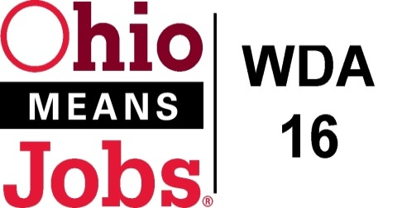
WDA 16

A proud partner of the
American Job Center network

COG Meeting
December 17, 2021 10:00 AM
In person at the Harrison Co JSF Office, 520 N Main Street Cadiz , OH

- Call to Order

- Roll Call

- Approval of Minutes (9/24/21)

- Financial/Participants Reports (Rob and Rebecca)
- Financial Report (October 2021).
- Allocation vs Expense Report

- Transfers:
Financial Report and Transfers were recommended for approval WDB16 Motion ___-2021
N Mod #2 Use of WIOA Admin for BRN from 11/20/21 to 12/31/21 $12,500
- WIOA Update: Staff Report
- Environmental Scan for Youth Elements
- Apprenticeship Update
- New Beginnings Special Grant awarded $92,976.71
- WDA OMJ Recertification due June 2022
- Burr Oak Career Conference Oct 27, 2021
- OWA Director position
- State Survey-Mckinsey and Co.
- Transfr VR

- OMJ Operations Reports

- BRN WIOA Grant Request $167,879.35 (1/1/22 to 6/30/23)

- New Beginnings Jefferson CAC Special WIOA Projects awarded $92,976.71
Jefferson CAC administration contract Recommended for approval by WDB16 Motion ____-2021

- Additional Discussions

- Next Meetings – Fri March 18, 2022 10am
Future Meetings: Proposed 2022 Meeting Schedule
Fri March 18, 2022 Fri June 10, 2022 Fri Sept 16, 2022 Fri Dec 16, 2022

- Adjournment

