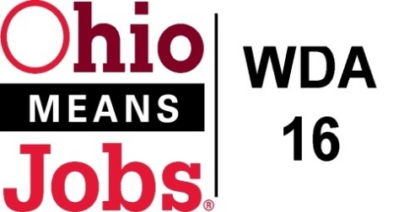
WDA 16

A proud partner of the
American Job Center network

Staff to the Board Report 3/11/22 Rob Guentter
Apprenticeship Updates:
Our BRN, Bradley Wells, is working with Eastern Gateway Community College (EGCC), a lead employer _____________ and a number of Jefferson Co schools (Edison, ___) to help support STNA training for high school students. There is a greater willingness for local schools to participate now that Ohio Graduation Seals are being required. The Business Advisory Committee and Bradley Wells are leading this effort.

OMJ Recertification: The state is requiring that all OMJs be recertified by June 30, 2022. Working with our May 2019 documentation for the prior recertification, we have come up with a short list of items that both of our Primary OMJs (Jefferson Co and Belmont Co OMJs) are assembling to complete our recertification review. The Board Recertification Committee will be reviewing this material for submission and recommendation to the WDB16 Board at your June 3, 2022 meeting.

Opioid 3 and New Beginnings updates: Opioid 3 officially ends in March and the program will end in February to allow time for program and financial closeout. The State has not yet heard back from DOL on their request to continue the program under the heading “New Beginnings”. Jefferson Co CAC is ready to go if and when the funding is approved.

Memorandum of Understanding (MOU): The MOU is the document that commits partners to fund our OMJ Centers. Usually a 2-year agreement, this year will only cover 7/1/22 to 6/30/23. This will allow Ohio to get these 2-year agreements back on the state biennium budget cycle. Staff has updated draft MOU Agreement and budgets and partners are being confirmed. This will also be on the June 3, 2022 WDB16 agenda for approval.

Data Share Agreement: For the second cycle, WDB16 has entered into a Data Share Agreement with Ohio. This has provided us with up-to-date Unemployment contact information to be used for our outreach efforts. We hope the state will also be providing us with employment and employer projections to assist our Business Outreach Team with better targeting efforts. This agreement runs to 9/30/23.

Incumbent Worker Training (IWT) update: Staff has been working with the Operators to develop and refine the application and monitoring paperwork needed to implement the IWT program that the Board approved in December. We now have everything ready to go. As we implement a few IWTs, I am sure we will learn a few things to further refine the process.

