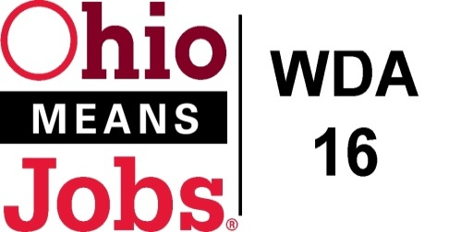
WDA 16

A proud partner of the
American Job Center network

Proposal Check List: Request for Proposals Adult and Dislocated Workers Due 4/7/22

Proposing Organization: ________________________________________________
County to Serve: _____________________________________________
Section 2
Agency Submitting Proposal Form 2-1 to 2-4
Technical Proposal-Narratives | ------------
- Agency Background
- Adult Dislocated Worker Program Summary
- Outreach, Recruitment and Referrals
- Performance History- Narrative and Form 2-6 to 2-8
Fiscal Agent Signature Page 2-9
 | -------------
Section 3 | -------------
Budget Form 3-1 to 3-5
 | -------------
Attachment D | -------------
Non Collusion Affidavit (Form provided)
 | ------------
Additional Items | ------------
This Check list
Submit application to rob@rfgassociates.net

i

