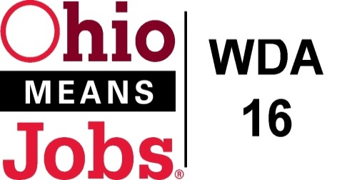
WDA 16

A proud partner of the
American Job Center network

COG Meeting
March 18, 2022 10:00 AM
In person at the Harrison Co JSF Office, 520 N Main Street Cadiz , OH

- Call to Order
- Roll Call

- Approval of Minutes (12/17/21)
- Financial/Participants Reports (Rob and Rebecca)
- Financial Report (January 2022)
- Allocation vs Expense Report

Transfers:

- WIOA Update: Staff Report

- Apprenticeship Update
- WDA OMJ Recertification due June 2022
- Opioid 3 and New Beginnings update
- Memorandum of Understanding (MOU)
- Data Share Agreement completed for 101/21 to 9/30/23

- OMJ Operations Report

- Approval to bid out Outreach RFP

- Additional Discussions

- Next Meetings – Fri June 10, 2022 10am
(Key meeting for annual 7/1/22 start contracts)
Future Meetings: Proposed 2022 Meeting Schedule
Fri Sept 16, 2022 Fri Dec 16, 2022

- Adjournment

