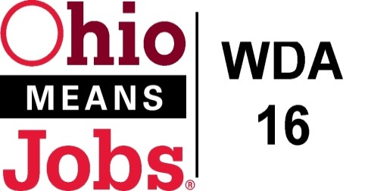
WDA 16

A proud partner of the
American Job Center network

3/23/22

Adult and Dislocated Worker RFP
Questions and Responses from 3/10/22 Pre-Bid Meeting and Questions Received before 4pm 3/18/22

Q1. Can the Adult Dislocated Worker RFP awardee provide /offer training services?
Q1 Response: As a general rule, the Adult and Dislocated Worker providers coordinate all client training services through recognized education and training providers in the region, and do not provide training services directly.
All training services, to be eligible for WIOA funding in Ohio, must be approved Eligible Training Providers (ETPs) and programs approved in the Ohio Workforce Inventory of Education and Training (WIET) system.

End of Q and A.

