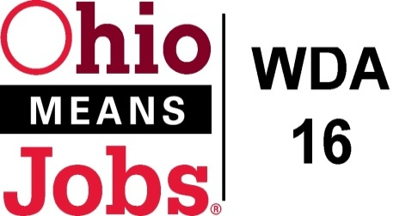
WDA 16

A proud partner of the
American Job Center network

CCMEP and Youth Services RFP
Responses to Questions received at the 3/10/22 Bidders meeting and all questions received by 3/18/22.

Q1 Can transportation provers refuse to serve youth?
Q1 Response: All solicitations in this RFP require bidders to serve youth ages 14-24. They can require parental approval forms for minors, and must fully comply with the safety and operational requirements in the supplemental Transpiration section in the RFP .

Q2 What needs to be submitted for the proposed budget?
Q2 Response: The RFP package includes budget forms and worksheets that all must be submitted with every proposal. If you have no planned expenses in any specific worksheet, submit that form indicating $0 budget expense.

Q3 Can we bid on groups of counties for a specific element?
Q3 Response: Bidders can bid on a single county youth element or any combination of counties where that youth element is requested. Each element by county, must have a separate set of application materials as detailed on the Proposal Checklist (page 31 in RFP package).

Q4 Does WDA16 have any data on the number of youth who need requested services in each county?
Q4 Response: At this time, the area does not have any detailed data addressing this question. The selected/needed youth elements in each county were determined by a Job and Family Services and County One Stop (OMJ) Center assessment of which of the WIOA 14 youth elements were being adequately addressed in the county, and were gaps in service availability exist. This RFP was developed based on the identified youth element service gaps.

End of questions

