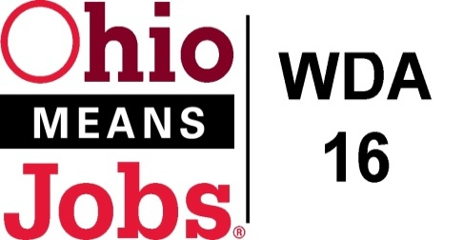
WDA 16

A proud partner of the
American Job Center network

RFQ for WDA16 Outreach
Questions and Answers to RFQ as of 4/5/22

Q1 For media purchases, do vendors get paid directly of do all payments flow through the selected outreach consultant?
Q1 Response: Payment for media purchases can be paid directly to the media vendor or through the outreach consultant. Proper documentation will be required in either event. The WDB16 preference is to handle everything through the outreach consultant.

Q2 Can we request proposal evaluator scoring?
Q2 Response: WDB16 operates under Ohio sunshine laws and would make rating sheets available upon written request.

Q3 Does any % of the outreach funding have to be used for Youth outreach?
Q3 Response: The outreach budget covers the four (4) counties of WQDA16 and there is no requirement for any % to be used for any specific population served.

Q4 Is there any current media options WDA16 likes or dislikes?
Q4 Response: WDA16 likes the social media outreach in that it provides the best data-based feedback of reach and impact. We really have limited feedback data on other the other components in our marketing mix to truly judge their effectiveness. The bidders would be wise to identify feedback and data mechanisms for each outreach component they recommend. This is an area we would like to improve to get the best return for our outreach investments.

End of Q and A.

