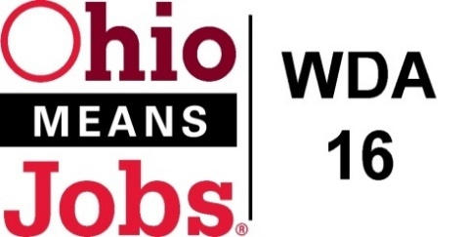
WDA 16

A proud partner of the
American Job Center network

WDB16 Board Meeting
June 3, 2022
10:00 AM
GoToMeeting

- Call to Order

WDB16 Board Meeting 6.3.22 10am
Fri, Jun 3, 2022 10:00 AM - 1:00 PM (EDT)

Please join my meeting from your computer, tablet or smartphone.

https://meet.goto.com/189642341

You can also dial in using your phone.
(For supported devices, tap a one-touch number below to join instantly.)

United States: +1 (224) 501-3412
- One-touch: tel:+12245013412,,189642341#

Access Code: 189-642-341

Get the app now and be ready when your first meeting starts: https://meet.goto.com/install

- Roll Call

- Approval of Minutes (3/11/22)

- Financial/Participants Reports (Rob and Rebecca)
- Financial Report (April 2022).
- Allocation vs Expense Report

- Transfers:

- CORSA Insurance 5/1/22 to 5/1/23 $3,020.00
- Ohio Workforce Association (OWA) PY22 Dues $3,850.00

- WIOA Update: Staff Report
- Apprenticeship Grant Update
- ARIES Update

- OMJ Operations Report

- Approval to accept $653,848 Fresh Start (opioid) grant and for
Jefferson Co CAC to administer from 3/1/22 to 3/31/24 as per the fee in the grant budget

- Approval of Evaluation contract with RFG Associates Inc. for Fresh Start (opioid) grant
$2,640 for 7/1/22 to 3/31/23

- Adult and Dislocated Worker Contracts Year 1 of 4 7/1/22 to 6/30/23
for Jefferson County: Jefferson Co CAC Inc. $500,224
for Harrison County: Jefferson Co CAC Inc. $114,217

- Youth Design and Framework Contracts Year 1 of 4 7/1/22 to 6/30/23
for Jefferson County: Jefferson Co CAC Inc. $873,263
for Harrison County: Jefferson Co CAC Inc. $307,568

- Outreach Contract Year 1 of 4 7/1/22 to 6/30/23
with _______________________ for $100,000

- Staff to the Board Contract Year 4 of 4 7/1/22 to 6/30/23
with RFG Associates Inc., Robert Guentter Jr. for $109,210

- Operator Contract Year 2 of 4, 7/1/22 to 6/30/23 as per MOU Agreement

- Youth Service Contracts, Year 1 of 4, 7/1/22 to 6/30/23 as per matrix, for Belmont, Carroll, Harrison and Jefferson Counties

- OMJ Site Recertifications for Comprehensive sites Belmont and Jefferson Counites
for Affiliate sites Carroll and Harrison Counites

- Library MOUs: Steubenville and Jefferson Co 7/1/22 to 6/30/24
Carroll Co District Library 7/1/22 to 6/30/24

- MOU with ODJFS

- WDA16 Subgrant Agreement with Ohio (maybe?)

- Policy Revisions to satisfy CCMEP Plans for all 4 counties:
04-2015 Youth Eligibility
01-2016 Standard Supportive Services
05-2017 Work Experience for WIOA and CCMEP Youth
02-2018 Follow-up
04-2018 Services to Families with a Close Relationship
01-2021 Youth Incentives

- Other Discussion

21 . Next Meetings – Fri Sept 9, 2022 10am GoToMeeting
Future Meetings: Fri December 9, 2022

22. Adjournment

