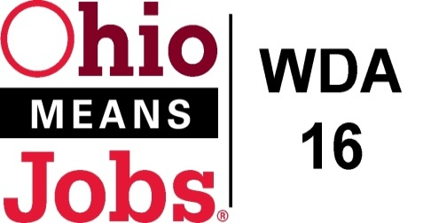
WDA 16

A proud partner of the
American Job Center network

Incumbent Worker Training (IWT) Grants Now Available for Local Businesses! 4/15/22
Serving Belmont, Carroll, Harrison and Jefferson Counties, OH

What is Incumbent Worker Training (IWT)?
IWT is a program to help upskill existing employees who have worked at a business for at least 6 months.
There are no employee income eligibility requirements for this program.

Any of the following factors create eligibility for an IWT program:
- Help a business retain employees, and/or
- Promote employees and potentially backfilling positions, and/or
- Avert layoffs, and/or
- Help make the employees and company more competitive.
IWT funding must be used for credential-based training or licensure and for Ohio critical or high demand jobs as determined by the Governor’s Office of Workforce Transformation https://topjobs.ohio.gov Preference will be given for training in for high demand jobs identified in the SE Ohio Workforce Sector Strategy in the sectors of Advanced Manufacturing, Healthcare and Shale Energy.
Uses of Training Funds
IWT can include funding for instruction, curriculum development, textbooks, manuals, training software , certification testing costs, and off-site facility costs. It cannot be used for capital equipment, workers training wages or management skills programs. All training must be provided by an Eligible Training Provider (ETP) approved by the Ohio Department of Education or Governor’s Office of Workforce Transformation and included on the Ohio Workforce Inventory of Education and Training (WIET) list. Owcms.ohio.gov/wiet/index.xhtml Company delivered training and government employee training is not eligible for IWT.
Expected Outcomes
Employees will be retained and or promoted and will earn at least a wage of $15.00 in Workforce Development Area 16 (WDA16).

IWT Process
Companies interested in participating in an IWT program must complete an IWT Application with their county Ohio Means Jobs (OMJ) Center. A Training Proposal with an approved ETP must be included with the application. OMJ staff will review the application and work toward approval. There will be an IWT Assurance and Certification Agreement and a Final Award Form between the company and the OMJ County. The Company will then enter into a contract directly with the ETP. OMJ will reimburse the company for documented and agreement approved training costs. There will be a 3-6 month required follow-up on the impact and outcomes of the IWT project.
Funding Availability
IWTs can provide up to 50% of the total cost of the training plan. 50% of the total cost must be provided by non-federal funding. WDA16 IWTs may be funded up to $500-$5,000 per participant and up to $25,000 per year (July 1-June 30) per business. For example, if the total training cost is $10,000 ($1,000 each person for 10 employees), then the IWT can fund $5,000 of the total cost. Employer paid training wages can be used as part of the required non-federal match
For more information, visit your local Workforce Development Area 16 (WDA16) Ohio Means Job Center in Belmont, Carroll, Harrison, or Jefferson Co. Or, visit www.OMJ16.com for Incumbent Worker Training information and the application package.

