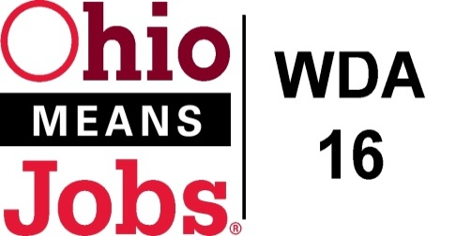
WDA 16

A proud partner of the
American Job Center network

Policy Letter 01-2021
Policy: Youth Incentives
Revised Motion 18-2022 6/3/22
PURPOSE

The purpose of this policy is to provide Incentives to Workforce Innovation and Opportunity Act (WIOA) and Comprehensive Case Management and Employment Program (CCMEP) eligible youth that encourages and motivates these youth to attain specific program goals and positive outcomes while enrolled in training, educational, and work experience activities.

- WORKFORCE DEVELOPMENT BOARD APPROVAL

Motion 31-2021 approved on September 17, 2021
This replaces Motions 19-2019 (5/31/19) and 18-2020 (9/18/20).
- BACKGROUND

Per Workforce Investment and Opportunity Act (WIOA), regulations at 20CFR part 681.640, incentives are an allowable service that can be provided to WIOA eligible youth for recognition and achievement directly tied to training, education, and work experiences. CCMEP youth participants are also eligible for these performance based incentives. CCMEP Youth participants funded under the TANF program are also potentially eligible for these performance incentives, in accordance with the incentive policy of the lead agency that is carrying out the TANF services in a county.

- IMPLEMENTATION

Incentives are not an entitlement. Incentives will be provided to the youth at the discretion of the Program Operator and are subject to available funding. Incentives may only be provided during enrollment and not after exit.

Incentives may only be cash payments (payable by check). The maximum payment to a youth for attaining one (1) program goal or positive outcome, is $100.00. During a Program Year (July 1-June 30), there is no limit to how many incentives a student can earn for achieving goals or outcomes.

Payment of incentives must be connected to the goals and objectives stated in the youth’s Individual Opportunity Plan (IOP).

Incentives may be issued to youth for attaining goals and positive outcomes including:
WDA16 Youth Incentives Policy Incentives | Financial award to youth if achieved
Primary or secondary school grade for each level advancement or GED progress | $100
Attainment of HS diploma/GED | $100
Successful completion of each educational/academic Credit Recovery Class | $100
Successful completion of Nationally Recognized Certification or Licensure program | $100
Obtaining Nationally Recognized Certification or License | $100
Successful completion of work experience as determined by the Program Operator | $100
Other training, educational, job shadowing and work experience activities as approved by the Program Operator, consistent with 20CFR 681.640 | $100
Additional Incentives allowed as per the ODJFS Toolkit
Earn an Ohio Jobs Readiness Seal (from required Ohio HS graduation list) | $100
Successfully complete a soft skills training program as approved by the Program Operator (i.e. Leadership, Financial Literacy, others linked to the 14 WIOA Youth Elements) | $100
Complete a FASFA | $100
Enroll in a post-secondary school | $100
Complete a semester of post-secondary school  (Minimum 2.5 GPA per semester to earn an incentive) | $100
Obtain unsubsidized employment | $100
Retain unsubsidized employment  (Incentive paid after 60 work days or 360 hours of work, whichever is less) | $100

Incentives may only be provided during enrollment and not after exit.

All WDB16 approved incentives are consistent with the 2021 guidelines provided in the CCMEP ODJFS toolkit:

https://jfs.ohio.gov/owd/CCMEP/docs/OnlineTrainingWorkExperienceandIncentivesToolKit.pdf

Documentation must be maintained by the Program Operator or Subcontractor and include at a minimum:

- Documentation of the Goal/Positive Outcome to be attained in the IOP
- Documentation of evidence of goal attainment
- Documentation that the Incentive was issued to the Youth

END

