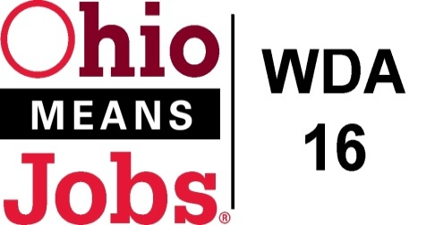
WDA 16

A proud partner of the
American Job Center network

COG Meeting Friday September 16, 2022 10:00 AM
In person at the Harrison Co JSF Office, 520 N Main Street Cadiz, OH

- Call to Order
- Roll Call

- Approval of Minutes (6/10/22)

- Financial/Participants Reports (Rob and Rebecca)
- Financial Report (July 2022)
- Allocation vs Expense Report

Transfers:
Usage of 300K youth old:
 |  | Move admin to program
Belmont | 35,186.21 |  | 35,186.21
Harrison | 32,813.79 |  | 32,813.79
Jefferson | 202,000.00 | 18,159.74 | 220,159.74
FA | 11,840.26 |  | 11,840.26
 | 281,840.26 | 18,159.74 | 300,000.00
Financials and Transfers recommended by WDB16 approval Motion22-2022
- WIOA Update: Staff Report
- Apprenticeship Update
- OMJ Centers Recertification approved
- Memorandum of Understanding (MOU) status
- ARIES Update
- TransfrVR Special Project $50,000 grant request recommended by WDB16 Motion 23-2022
- CCMEP Enrollment and Services

- OMJ Operations Report

- Library MOUs: Puskarich Public Library (Harrison Co.) 2022-2024
Recommended by WDB16 approval Motion 24-2022

- WDA16 2022-2023 Performance Goals
Recommended by WDB16 approval Motion 25-2022

- Other Discussion

10. Next Meetings – Friday December 16, 2022 10am GoToMeeting
Future Meetings: 2023 schedule will be presented at 12/16/22 meeting

11. Adjournment

