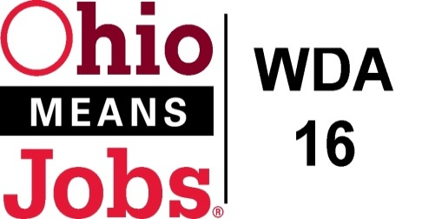
WDA 16

A proud partner of the
American Job Center network

Policy Letter 03-2019
Policy: Retention of Records
Purpose
The purpose of this policy is to provide workforce development agencies, contractors and sub-contractors with policies and procedures on the proper retention of records.
Workforce Development Board Approval
Motion: 40-2019 approved on 12/6/2019
This replaces Local Policy Letter 15-2004, which was approved on October 14, 2014.
Implementation
- SUBGRANTEE, Workforce Development Board 16 (WDB16), and AGENT will retain all records related to funds provided herein in accordance with 2 CFR 200.333 through 200.337, OAC 5101:9-9-21, and all state and federal record retention requirements for a minimum of three (3) years after SUBGRANTEE receives an allocation or payment issued. If an audit, litigation, or similar action is initiated during this time period, the records must be retained until the action is concluded and all issues are resolved or until the end of the 3-year period, whichever is later.

Exceptions to the above include:

- Records for real property and equipment acquired with federal funds shall be retained for three (3) years after disposition.

- All such records shall be maintained in such a manner that will preserve their integrity and admissibility as evidence in any audit, litigation, or other proceedings. The burden of production and authentication of the records shall be on the custodian of the records. While no specific media for record retention is specified, the custodian must ensure that the methods used ensures that the security safeguards and protections are
sufficient for the records to be acceptable by a court as evidence. In addition, the custodian must ensure that a satisfactory plan of recovery exists should critical records be lost in the event of fire, vandalism, or natural disaster.

- Rights of timely and reasonable access to pertinent books, documents, papers or other electronic records of grant recipients, sub recipients, vendors and others, must be granted to the WDB Fiscal agent, US Department of Labor, State of Ohio, grant recipients, or any other authorized representative to make audits, examinations, excerpts and transcripts as they deem necessary.

END

