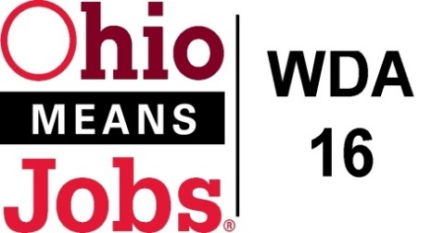
WDA 16

A proud partner of the
American Job Center network

Policy Letter 07-2015
Policy: Conflict of Interest Code for the Workforce Development Board and Youth Council Members
PURPOSE

This purpose of this policy is to establish a Conflict of Interest Code for members of the Workforce Development Board and Youth Council to serve without bias in the oversight of the Workforce Innovation and Opportunity Act (WIOA).

- WORKFORCE DEVELOPMENT BOARD APPROVAL

Motion 35-2015 approved on Nov 20, 2015.

- POLICY CANCELLATION

Policy Letter 11-2004 approved October 14, 2004

- POLICY LETTER IMPLEMENTATION

- Restricted Activities:

    - No member on the Workforce Development Board or Youth Council shall:
- Cast a vote or participate in any decision-making capacity on any matter under consideration:

        - Regarding the provision of services by such member (or by an entity that such member represents); or
        - That would provide direct financial benefit to such member or the immediate family of such member.

      - Engage directly or indirectly in any business transactions or private arrangement for profit which accrues from or is based upon his or her official position or authority on the Board.

      - Participate in the negotiation of or decision to award contracts or grants, the settlement of any claims or charges in any contracts or grants, the certification of any eligible providers or the establishment of any designation of local workforce investment areas or the establishment of any one stop delivery systems, with or for any entity in which he or she has a financial or personal interest.

      - No individual may be placed in a Workforce Innovation Opportunity Act employment activity if a member of that person’s immediate family is directly supervised by or directly supervises that individual.

- Representation of interests:

    - No member of any of these Boards shall represent or act as an agent for any private interest whether for compensation or not, in any transaction in which the Board has a direct and substantial interest and which could be reasonably expected to result in a conflict between a private interest of the Board member and his official Board responsibility.

- Misuse of Board facilities and equipment

    - No member of the Board shall use any Board equipment, supplies or properties for his or her own private gain or for other than official designated purposes.

- Duties of Board Members:

    - It shall be the duty of all Board members to:

      - Recuse themselves from their official Board duties if there is a conflict of interest.

      - Advise the Board of any potential conflicts of interest

      - Ask the Board for an opinion if they have any doubts that a specific situation involves a conflict of interest.

- Violations of the Conflict of Interest Code:

    - If after an investigation, the Board believes that this code has been violated it can recommend to the Governor or the Chief Elected Officials of the Workforce Development Area 16 that the individual who has violated the code be removed as a member of the Board.

    - The Governor or the Chief Elected Officials of the local workforce investment area has the authority to remove a member of the Board for a violation of this code, even if the Board has not made such a recommendation.

- REQUIREMENTS

All requirements mandated by WIOA, and all other applicable Local, State and Federal requirements as they apply to the WIOA will be met. Additional added requirements may be added at the discretion of the WDB.

- DURATION

An approved policy is in effect until superseded by a revision or repealed by the WDB.

VI. WIOA CONFLICT OF INTEREST SIGNATURE FORM.

I hereby acknowledge that I have received a copy of Policy Letter 07-2015, Conflict of Interest Code for Workforce Development Board and Youth Council Members.

________________________________________
Name -- PLEASE PRINT

_________________________________________
Signature Date

_________________________________________
Workforce Development Board or Youth Council

