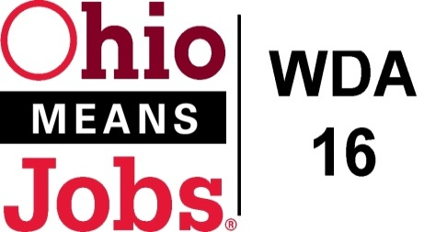
WDA 16

A proud partner of the
American Job Center network

Policy Letter 11-2015
Policy: Priority of Service for Veterans and Eligible Spouses

PURPOSE

To outline requirements for implementation of priority of service to veterans and eligible spouses (Covered Person) for all DOL funded training programs.

- WORKFORCE DEVELOPMENT BOARD APPROVAL

Motion 06-2016 approved on February 19, 2016.

- POLICY CANCELLATION

Policy Letter 02-2004 approved July 29, 2004

- POLICY LETTER IMPLEMENTATION

- Background:

Recipients of DOL funds for qualified job training programs have been required to provide priority of service since 2002 as outlined in the Jobs for Veterans Act (JVA), Public Law (P.L.) 107-288. The publication of 20 C.F.R. Part 1010, Priority of Service for Covered Persons; Final Rule, which took effect on January 19, 2009 declares that recipients of DOL funds for these job training programs should review and, if necessary, enhance their current policies and procedures to ensure that acceptable protocols are in place. The Workforce Innovation and Opportunity Act Policy Letter No. 15-20 dated December 21, 2015 states; each local area is required to develop a priority of service policy.

- Requirements
Priority of service means that covered persons are given priority over non-covered persons for the receipt of employment, training, and placement services funded in whole or in part by DOL, including Wagner-Peyser, Trade Adjustment Assistance (TAA), Workforce Investment Act, Senior Community Service Employment Program, Indian and Native American Programs, Migrant and Seasonal Farmworkers, Workforce Innovation in Regional Economic Development Competitive Grants, and National Emergency Grants.

- Procedures
Individuals entering the OhioMeansJobs Center are identified at the point of entry upon completing registration. This is done by utilizing our sign in sheets or by asking if the individual is a Veteran.

Utilizing the Veteran Questionnaire (JFS Form 01863), an individual who is identified as a veteran or covered person will be referred through the designated workflow identified in the attached diagram. During the intake process, designated staff will further explore the covered person’s veterans status (e.g., number of days served and discharge status) and assess whether or not the covered person has a significant barrier to employment. If the covered person has at least one of the identified barriers to employment, and meets the definition of eligible veteran or eligible spouse or any other service group identified by the Jobs for Veterans State Grant (JVSG) along with the time and service requirements, they will be referred to the assigned Disabled Veteran Outreach Program Specialist.

The Veteran Questionnaire also gives permission for staff and OhioMeansJobs (OMJ) partners to exchange and disclose necessary information in order for services to be provided by all programs being administered by OMJ and/or other partners.

In additional to the Veteran Questionnaire we will also raise awareness of priority of services through posters and handouts strategically placed at the OhioMeansJobs Centers to alert covered persons of their priority of service rights.

Priority of service rights is addressed on the OhioMeansJobs Center’s websites or other portals by which job seekers remotely access resources, including self-service resources.

WDB 16 assures that labor exchange activities and services, including posting of and searching for resumes and jobs and job matching are completed in OhioMeansJobs.com per Workforce Investment Act Policy Letter (WIAPL) No. 13-04, Mandate Use of OhioMeansJobs.com for Job Placement and Referral Activities in Ohio , and veterans are given priority of service.

The Ohio Department of Jobs and Family Services Veteran Program Managers, and the local OMJ Operator shares monitoring responsibilities through regular OMJ partner meetings. Monitoring responsibilities include a review of the implementation of internal policies and procedures and how they are in compliance with the priority of service requirements. All OhioMeansJobs Center staff receive in-service training on the implementation of priority of service for veterans and eligible spouses.

END

