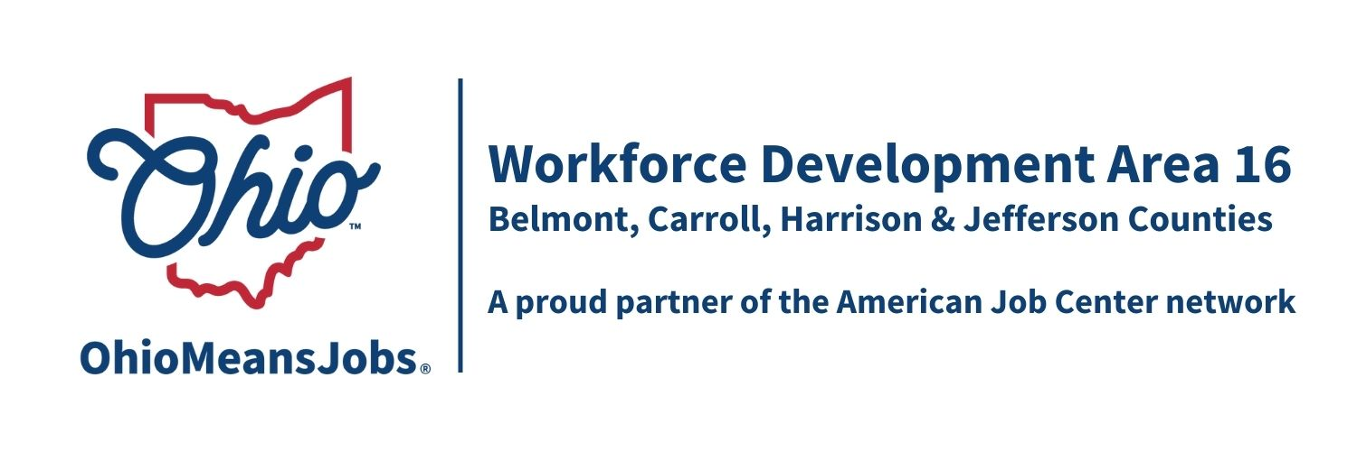
WDB16 Board Meeting
March 15, 2024
10:00 AM
GoToMeeting

- Call to Order
WDB16 Board Meeting 3.15.24
Fri, Mar 15, 2024 10:00 AM - 12:00 PM (EDT)
Please join my meeting from your computer, tablet, or smartphone.
https://meet.goto.com/661790133
You can also dial in using your phone.
(For supported devices, tap a one-touch number below to join instantly.)
United States: +1 (571) 317-3122
- One-touch: tel:+15713173122,,661790133#
Access Code: 661-790-133

- Roll Call

- Approval of Minutes (12.1.23)

- Financial/Participants Reports (Rob and Rebecca)
- Financial Report (Jan 2024) -handout
- Allocation vs Expense Report
- State Audit update

- Transfers/Bills to Pay
- RFG Associates Inc. reimbursement for hotspot for VR headsets $1,075.07
- Business Resource Network (BRN) return funding to the state $15,000.

- WIOA Update: Staff Report
- TransfrVR update
- Virtual Job Fairs
- Gener8tor on-line IT training
- GRIT (Growing Rural Independence Together)
- WDB16 Board reauthorization with ODJFS
- Ohio Means Jobs Re-Branding
- Jason Project
- Rapid Response Plan update
- Broadband OU
- Belmont Co Job Fair April 17, 2024 1-4pm

- OMJ Operations Report

- Resolution Recognizing long term Board member Bob Hendricks

- William Moore to WDB16 Outreach Committee and to Recertification Committee (By Chairperson)

- Data Share Agreement: Authorize the Staff to the Board to negotiate and to have signed the Data Share Agreement with ODJFS.

- GRIT: Authorize entering an MOU with WDA1 for $400,000-$500,000 of GRIT funding through 2025 to address gaps in WDA16 workforce services.

- Rebranding Funds: Accept and expend $17,000 from ODJFS for rebranding activities in WDA16.

- BuildEd: Authorize the purchase of up to 10 client units of BuildEd Career Ownership, Performance and Advancement Training at $965/client, not to exceed $9,650. This training will be used with selected at-risk OMJ clients as a demonstration of the programs’ effectiveness.

- Request and Accept Supplemental WIOA Youth Funding:
Authorize the request for and acceptance of $86,511 of supplemental WIOA Youth funding, with priority redistribution to Belmont County.

- Monitoring Policy: Revise PL01-2018 (revised Motion 18-2020) with revisions to Monitoring Tool

- Priority of Services Policy: Approve PL 01-2024 to replace PL 02-2014.

- Other Discussion

Discussion topic next meeting: 14 Youth Elements and contract renewals

- Next Meetings – Fri June 14, 2024 10am GoToMeeting
Fri Sept 13, 2024 10am In person Cadiz Location TBD
Fri Dec 6, 2024 10am GoToMeeting

- Adjournment

