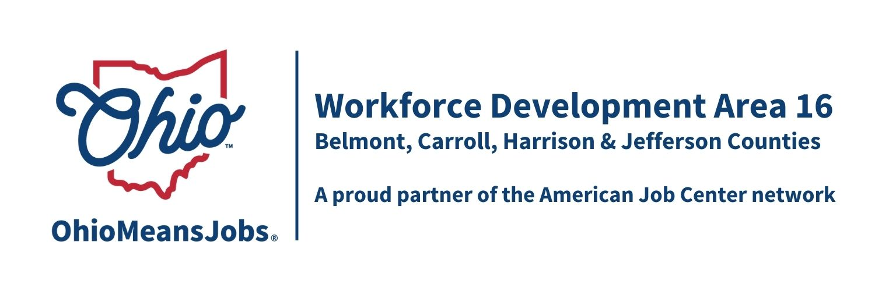
Staff to the Board Report 3/15/24 Rob Guentter
TransfrVR Career Exploration: From Feb.2023 the end of Dec. 2023, we have had 500 viewed simulations with the VR Career Exploration headsets, and with great feedback. We now have 43 simulations, with the newer versions coming soon. We are looking into funding to extend the project beyond October 2024.

Virtual Job Fair: After a successful run with using Premier Virtual for virtual job fairs during the pandemic, usage by business and job seekers has dwindled. We recommend not renewing the Premier Virtual contract.

Gener8tor: After working with Springboard for on-line IT training, we are now looking too Genera8tor. They offer CompTIA IT certifications and can provide remote employment, like Springboard. This training is intended to allow residents to stay in our area and work remotely, not having to move away. New investments in broadband show make this more practical for residents in the years ahead.

GRIT (Growing Rural Independence Together): Area 16, for the first time, now qualifies for GRIT funding. GRIT is an Ohio funded program to help youth and adults prepare for the workforce, without the rules and regulations of WIOA funding. It is intended to fill gaps in workforce preparation, using a state-of-the-art assessment (Future Plans), mandatory career counseling, and focused job training/education and work experience. They are considering $400-$500K for Area 16 to be used for our Career Navigators, administrative work to meet GRIT requirements, and youth/adult job training.

WDB16 Board Reauthorization: Every 2 years county commissioners appoint/reappoint members to the WDB16. Upon appointments, all members must sign Conflict of Interest forms and the Board must meet the guidelines for local participation. We are just waiting for a new business appointment in Harrison Co, replacing long-time Board Member Bob Hendricks, to complete this process.

OhioMeanJobs Re Branding: The state has decided to rebrand all Ohio logos including Ohio Means Jobs. Branding The state will be providing up to $4,000 per county plus $1,000 for the area for this project ($17,000 total). Signage is being finalized and we are considering any remaining funding for other area branding activities to order in quantity. We have until June 2024 to get this all done. The state is also looking to standardize all Facebook workforce addresses as well. The last rebranding occurred in 2017.

Jason Learning: The area is looking into a regional partnership (WDA 14, 15 and 16) to use Jason Learning for targeted workforce curriculum development to meet the needs of local employers. Jason is currently serving over 6 million students in the USA. While the Jason materials look impressive, the real impact will happen when/if we can figure out how classroom teachers can best utilize this program. School interest is key to this and the OMJs will have minimal involvement. Mor info at https://jason.org

Broadband: The area is partnering with Ohio University /Quest Project to help expand and promote Broadband training opportunities in the region. A copy of current training courses is provided in the Board package. Over $500,000 will be invested in Ohio broadband infrastructure expansion over the next few years.

