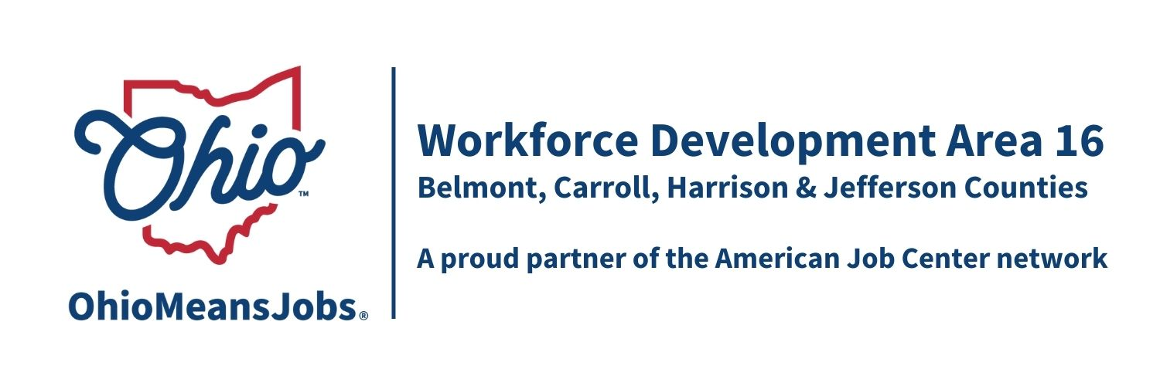
WDB16 Staff to the Board Report 9/13/24

TransfrVR update: Our VR contract ends in October 2024, and each of our counites has agreed to provide TANF funding to procure at least 1 VR headset each. We will also have the availability to borrow units from GRIT, if we have the need. Additional career exploration units will be provided with this renewal, taking us over 50 career exploration experiences.

GRIT (Growing Rural Independence Together): GRIT has awarded $196,375 for Jefferson Co., $91,980 for Carroll Co. and $20,000 for the Area (to cover local match for the ARC ARISE Apprenticeship Planning grant), for a total of $308,355. Jefferson and Carroll Cos are working to implement their funding.

Rapid Response Plan update: Representatives from all 4 counties met with the State Rapid Response Coordinator on 3/12/24 and we have drafted a revised rapid response plan for the area. A Rapid Response Plan outlines what everyone needs to do in case of a plant closing in the area. By planning, we all know our roles and can react more quickly. We are waiting for the state to send us the final version.

Data Share Agreement: Our Data Share Agreement with the state is fully signed and is good until 9/30/26.
.
BuildEd update: BuildEd staff delivered a training for our OMJ staff on 8/19/24. There was a positive discussion, and we look forward to seeing how this 10-person demonstration project, focusing on helping individuals understand their real performance role with an employer, works out. At $965 per client, this may prove to be a great investment. (handout)

WIOA Reauthorization: The House has voted out their version of” A Stronger Workforce for America Act” (ASWA), which will replace WIOA. The House significantly cut adult funding and eliminated youth funding. The Senate now has the bill in committee and appears to be looking to recommend funding for adult, dislocated workers, and youth at slightly higher rates than we currently have. This matches the administration’s proposal. Those in the know say that nothing is likely to happen before the election. However, during lame duck time, if Harris wins the Presidency, the Republicans may push for passage to cut workforce funding as much as they can. If the Democrats win, expect them to hold off any voting until they assume power.

WIOA Performance Measures: The state has proposed WDA16 WIOA performance targets for PY24 and PY25. We are looking to negotiate a few of them to assure the area can meet compliance. Of particular concern is meeting Credential Attainment and Measurable Skill Gains targets. This is due to the closing of our largest regional post-secondary school, Eastern Gateway Community College. Our formal conference call with the state is set for September 23, 2024.

