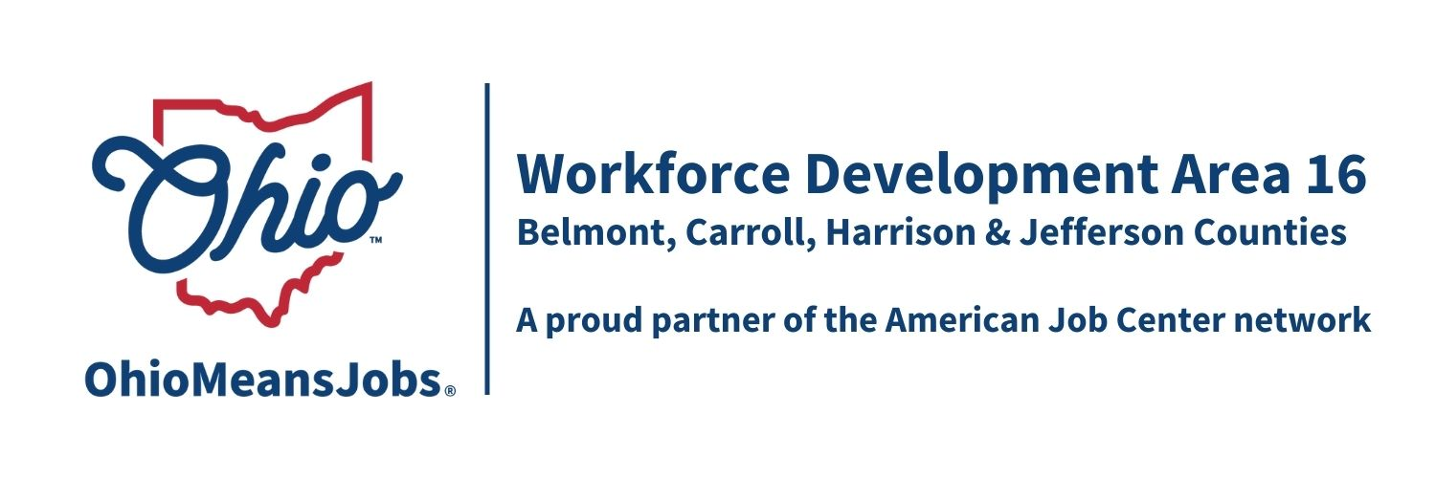
2025 Planned Meeting Schedule for Workforce Development Board 16 (WDB16) and the Area 16 Council of Governments (COG)

Proposed Workforce Development Board (WDB16) 2025 meeting dates (all at 10:00am):
Friday March 14, 2025 GoTo virtual meeting
Friday June 13, 2025 (in person location TBD);
Friday September 12, 2025 GoTo virtual meeting, and
Friday December 5, 2025 GoTo virtual meeting

Proposed 2025 COG dates (all at 10am) at the Harrison Co JFS Office,
520 N. Main St Cadiz OH 43907
Friday March 28, 2025;
Friday June 20, 2025;
Friday September 26, 2025; and
Friday Dec 19, 2025

Updated 12/12/24

