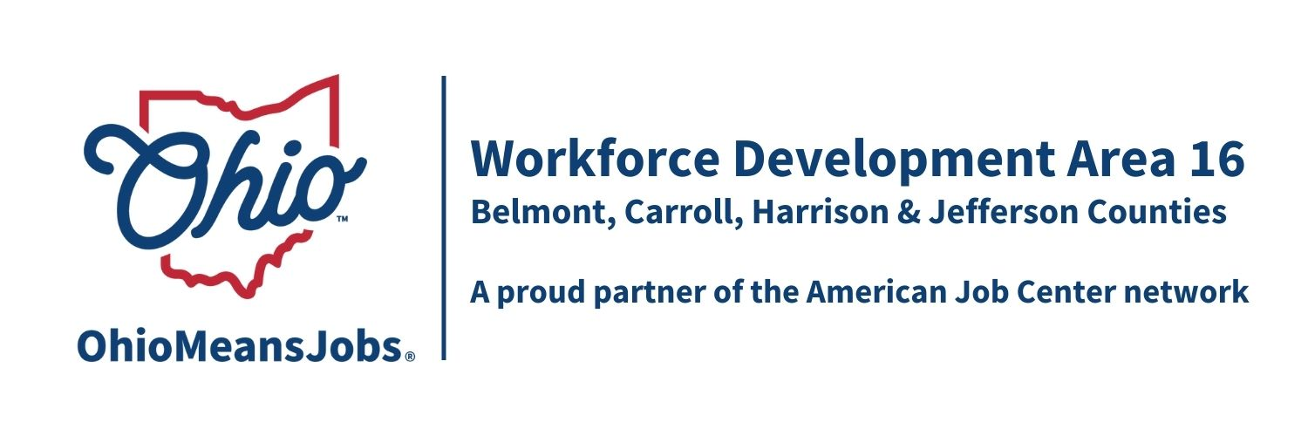
COG Meeting Friday December 20, 2024 10:00 AM
In person at the Harrison Co JSF Office, 520 N Main Street Cadiz, OH

- Call to Order

- Roll Call

- Approval of Minutes (September 27, 2024)

4. Financial/Participants Reports (Rob and Rebecca)
- Financial Report (October 2024)
(Recommended by WDB16 Motion 25-2024)

5, Transfers: None

6. Staff to the Board Report

- WIOA and RESEA Reauthorizations
- Complaint Procedure 04-2017 (May 2020 last update) Updated contacts
- Outreach Committee and update
- Local and Regional Workforce Plan update
- TransfrVR Update
- Performance Reviews and CIPs (Belmont, Carroll and Jefferson Cos)

- Data Share Agreement Revision- Remove all conditions except RESEA
(Recommended by WDB16 Motion 26-2024)

- Next Meetings – Fri March 28, 2025 10am Cadiz
Proposed 2025 COG dates (all Fridays at 10am) March 28, 2025; June 20, 2025; September 26, 2025; and Dec 19, 2025

- Open Discussion

- Adjournment

