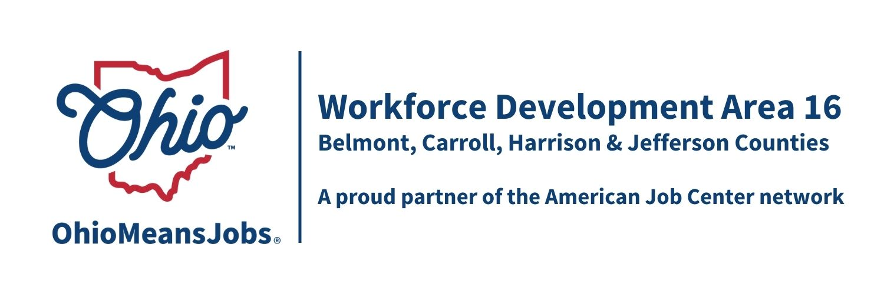
AREA 16 Council of Government (COG)
Meeting Minutes
Sept 27, 2024
Harrison Co DJFS, 520 N. Main Street, Cadiz OH

Present: Michelle Santin, Jefferson Co. JFS Director for Tony Morelli (Jefferson Co.), Don Leggett, Commissioner (Carroll Co), Dustin Corder Harrison Co Commissioner, and Jeff Felton, Belmont Co. JFS Director for Josh Meyer (Jefferson Co.)

Visitors: Nicole Paulette, Rebecca Safko, Deb Knight, Mike Schlanz, Hope McAfee, Kate Offenberger, Jacob Barr, Jennifer Burns, Jana Kizito, Hannah Titi, Lisa Duvall, and Rob Guentter

- Call to Order:
Meeting called to order by Acting Chair Dustin Corder at 10:06am.
A quorum of COG members was present to conduct business.

- Approval of Minutes:
Motion 18-2024 to approve June 21, 2024, COG Minutes as written.
1st-Santin 2nd Felton Motion Carried

- Financial/Participant Reports and Transfers (Rebecca):
Rebecca reviewed the July and August 2024 financials.

Transfers:
(Recommended for approval by WDB16 Motion 20-2024)
- $1,100 Admin to Jefferson Co (county cost allocation plan)
- $5,035.78 Adult from Carroll to Belmont (expiring $)
- $5,906.34 Dislocated Worker (DW) from Carroll to Belmont (expiring $)
- $848.32 branding grant from Carroll Co to Jefferson Co: Mod 1 Purchase of Service Contract with Jefferson Co CAC (Branding) from $8,000.00 to $8,484.32
- $122,839 Area 16 State Supplemental Dislocate Worker (DW) to Jefferson Co as needed.

Motion 19-2024 Motion to approve financial report and transfers, as described above
1st Santin 2nd- Felton Motion Carried

- WIOA Update: Staff Report (Rob)
Rob provided a written report on the following topics:
- TransfrVR update
- GRIT (Growing Rural Independence Together) update
- Rapid Response Plan update
- Data Share Agreement
- BuildEd update (handout)
- WIOA reauthorization
- WIOA Performance Measures PY24-25 (handout)
- Contractor Evaluations (Rob, Staff to the Board by WDB16 Board and Rebecca, Fiscal Contract with Belmont Co DJFS)

Rob also shared that the WDB16 is evaluating his performance (as Staff to the Board) and the Belmont Co is evaluating Rebecca Safko (fiscal contractor) performance, as recommended by a recent monitoring from the state. Both performance evaluations are underway.

- OMJ Operator Reports

Belmont Co: Mike Schlanz reviewed the Belmont Co data handout report. Highlights included that 9 of 10 TANF SYEP and 32 of 37 summer youth successfully completed the summer work experience programs. 23 worksites were involved. Further, 16 businesses placed work orders at the OMJ this period.

Carroll Co: Jennifer Burns shared that during this period they had 525 visits to the OMJ Resource Room, 28 UI visits, and served 49 new job seekers. ASPIRE had 87 students at the OMJ as well. Recent outreach has included Carrollton and Malvern School Board meetings to promote OMJ and CCMEP programs.

Harrison Co.: Jacob Barr also reviewed his submitted Board Report data. He is working to identify new job sites and had 8 new job seekers at the OMJ this period.

Jefferson Co: Hope McAfee highlighted their report by indicating 231 CCMEP students, 237 Fresh Start clients, 13 GRIT, 61 Adult, and 7 dislocated Workers (DW) were served since July. The Sept 18 OMJ Jefferson Co Job Fair at Florian Hall had 61 vendors and 106 job seekers. Kroger hired 3 persons at the event. Based on a survey of job seekers, most said they heard about the job fair from friends and family.

Hope also gave an update on the Remeplyment Services and Eligibility Assessment (RESEA) program. This effort is meant to help hard to place or long-term unemployed people get extra services to secure employment. While this used to be a state administered program, in recent years it has been locally delivered. The state still determines who will be offered/or mandated this help and sends contact information to us. WDA16 uses Jefferson Co. CAC to run the program for all four WDA16 counties. The state has recently added a required 45 minute online or in person workshop/video (REACH) and is evaluating the overall impact of the RESEA program. She also said the Ohio ID log in requirement is causing trouble for a lot of clients, especially around emails that do not match state records.

- Other Discussion: None

- Next Meeting Fri December 20, 2024, 10am at
Harrison Co DJFS Office, Cadiz OH

Proposed 2025 COG dates (all Fridays at 10am) March 28, 2025; June 20, 2025; September 26, 2025; and Dec 19, 2025

- Motion to Adjourn
Motion 20-2024 Motion to Adjourn
1st Santin 2nd- Felton Motion Carried

Adjournment- 10:56am

_________________________________________________ _____________
COG Chair Date

