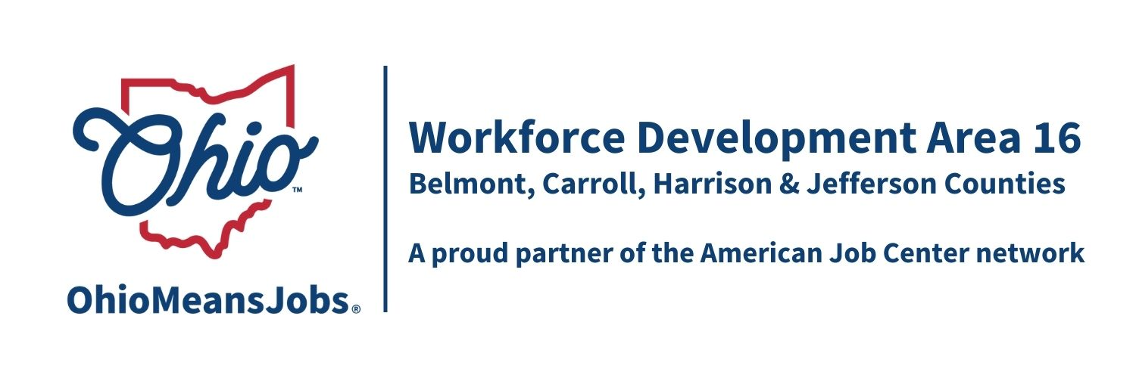
WDB16 Staff to the Board Report 12/6/24

WIOA and RESEA Reauthorizations: The House has voted out their version of” A Stronger Workforce for America Act” (ASWA), which will replace WIOA. The House significantly cut adult funding and eliminated youth funding. The Senate, to date, has taken no action.
Now that the election went to the Republicans, it is likely that they will work to draw up the reauthorization of workforce training in their own image. That means smaller and more targeted. There is an effort for a bill to be passed in lame duck congress.
However, support for unemployed individuals just got a boost with the surprise reauthorization of RESEA (Reemployment Services and Eligibility Assessment) at a higher funding level. We are looking at how we can use RESEA in more comprehensive ways to offset the likely cuts in our traditional workforce funding.
Complaint Procedure 04-2017: This local policy has been updated to include current contact information for the area.
Outreach Committee and Update: We need to appoint at least 1 additional Board member to the Outreach Committee and set a committee meeting with our outreach vendor er to discuss/revise outreach strategies within our new smaller budget. Current members include Karla Martin, William Moore and Nicole Paulette. The operators also need to select a committee representative, given the retirement of Mike McGlumphy.
Updated Local and Regional Workforce Plan: The updated workforce plan is expected to be completed by June 2025. The workforce directors in Ares 14, 15 and 16 are working together to “divide and conquer” update sections, like we did for the last update. There will likely be a survey distributed to Board members in all 3 areas as well as other stakeholder input. A Regional Planning Summit is being organized, to be held in Marietta, Jan 22-24, 2025. We are hoping for around 4-6 workforce board members from each area to attend, with travel, lodging, meals, and registration expenses covered. Please consider attending. More details to follow.
TransfrVR update: Each county has agreed to us TANF funding to continue with 1 Career Exploration headset into 2025. Jefferson is getting 2. We are in the process of returning 5 headsets this month.

Performance Reviews and CIPs (Continuous Improvement Plans): Belmont, Carroll, and Jefferson Cos had some minor issues with their performance reviews for 2023. These issues have been addressed, responded to in a formal CIP to the state, and the state has accepted all submitted CIPs.

ARC Grant Awarded: WDB16 supported an application from the Ohio Natural Energy Institute, Ohio Oil and Gas Association, for $50,000 to work on strategies and workforce considerations to reduce methane gas releases in their industry. This is a critical issue in the effort to reduce global warming. We received a thank you letter from the association for our support.

