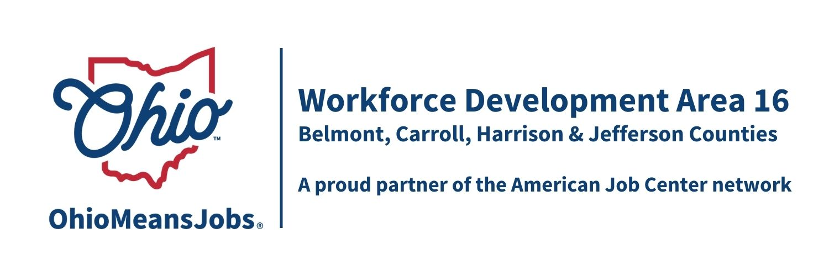
COG Meeting Friday March 28, 2025 10:00 AM
In person at the Harrison Co JSF Office, 520 N Main Street Cadiz, OH

- Call to Order

- Roll Call

- Approval of Minutes (December 20, 2024)

4. Financial/Participants Reports (Rob and Rebecca)
- Financial Report (Jan 2025)

Transfers: Accept $41,913 reallocation of State RESEA to Dislocated Worker (DW)
all to Jefferson Co
Accept $4,657 of additional DW Administrative funding
(Financial Report Recommended by WDB16 Motion 02-2025)

5. Staff to the Board Report
- WIOA and RESEA Reauthorizations
- Local and Regional Workforce Plan update
- WDB16 2-year Board appointments/recertification
- Memorandum Of Understanding (MOU) 2-year agreement
- OMJ Center Recertifications
- WDA16 Subgrant Agreement with Ohio and county subgrant agreements

- Staff to the Board Contract: Year 3 of 4
(6-month renewal 7/1/25 to 12/31/25 not to exceed $61,750)
(Recommended by WDB16 Motion 05-2025)

- County Board Reports

- Next Meetings – Fri June 20, 2025 10am Cadiz
Future 2025 COG dates (all Fridays at 10am): September 26, 2025; and
Dec 19, 2025

- Open Discussion

- Adjournment

