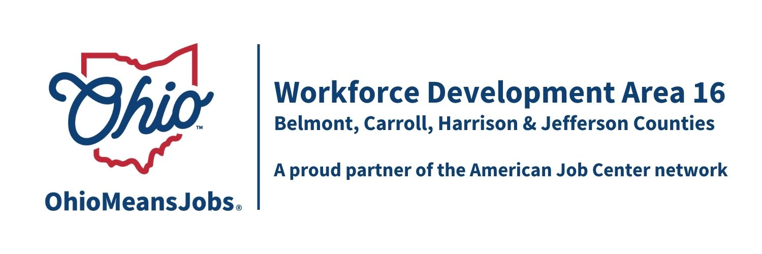
2026 Planned Meeting Schedule for Workforce Development Board 16 (WDB16) and the Area 16 Council of Governments (COG)

Proposed Workforce Development Board (WDB16) 2025 meeting dates (all at 10:00am):
3/13/26 virtual GoToMeetings
6/5/26 In person in Cadiz, location TBD
9/11/26 Virtual, platform TBD
12/4/26 Virtual, platform TBD

COG: All at 10am at the Harrison Co DJFS Office, 520 N. Main St Cadiz OH
3/20/26 In person, Harrison Co DJFS Office, 520 N. Main St Cadiz OH
6/12/26 In person, Harrison Co DJFS Office, 520 N. Main St Cadiz OH
9/18/26 In person, Harrison Co DJFS Office, 520 N. Main St Cadiz OH
12/11/26 In person, Harrison Co DJFS Office, 520 N. Main St Cadiz OH

Updated 2/4/26

