-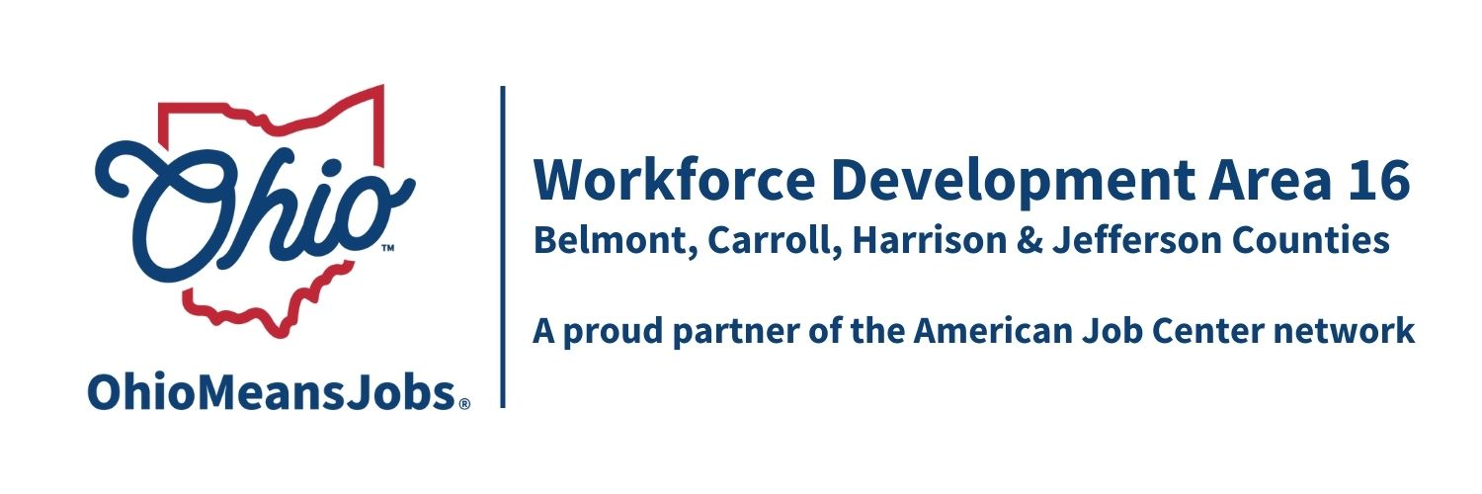
WDB16 Board Meeting
3/13/26
10:00 AM
GoTo Meeting

WDB16 Board Mtg 3.13.26 10am
Mar 13, 2026, 10:00 AM – 12:00 PM (America/New York)
Please join my meeting from your computer, tablet or smartphone.
https://meet.goto.com/914433637
You can also dial in using your phone.
Access Code: 914-433-637
United States: +1 (224) 501-3412
Get the app now and be ready when your first meeting starts:
https://meet.goto.com/install

- Call to Order

- Roll Call

- Approval of Minutes (12.5.25)

- Financial/Participants Reports (Rob and Rebecca)
- Financial Report (Jan 2026)
- Allocation vs Expense Report
Transfers: None
Accept additional state funds:
- Accept $21,000 for additional RESEA services and modify contract with Jefferson County CAC for this amount.

- WIOA Update: Staff Report
- WIOA Reauthorization
- WDB16 2-year Board appointments/recertification-Approved
- OMJ Center Recertifications-All 4 counties OMJs recertified
- ARC ARISE Apprenticeship update
- 4-year Youth Elements Assessment
- AI Eligibility and Tracking Project Special Grant update
- Industry Sector Partnership (ISP) Activity in WDA16

- OMJ Operator Reports

- Cyber Policy: Approval of WDB16 Cyber Policy to meet ORC 9.64 cybersecurity requirements

- ARC-ARISE Apprenticeship Implementation Grant: Approve not to exceed $1,000 for application/grant preparation fee to grant fiscal agent, SW Corner Workforce Development Board, Washington Greene Co Job Training Agency Inc.

- Library MOUs 2026-2028 Approval of the following Library MOUs:
- Belmont Co: Bellaire Public Library, Belmont Co District Library, Barnesville Hutton Memorial Library
- Carroll Co: Carroll Co Library District
- Jefferson Co: Public Library of Steubenville and Jefferson Co

- RFP Approvals: Approve the following RFPs to be prepared, publicly advertised, and evaluated by the WDB16 Executive Board.

- Youth Elements (all 4 WDA16 counties) as per each County assessment
effective 7/1/26-6/30/30
- Outreach Contract ($ 10,000 to $40,000 recommended) effective 7/1/26-6/30/30
- Jefferson Co. Youth Design and Framework effective 7/1/26-6/30/30
- Jefferson Co. Adult and Dislocated Worker Framework and Design
effective 7/1/26-6/30/30

- Staff to the Board RFP effective (7/1/26-6/30/30)

- Other Discussion

- Next Meetings –Fri June 5, 2026 (Puskarich Public Library Cadiz OH) 10am
9/11/26 GoTo, and 12/4/26 TBD

- Adjournment

