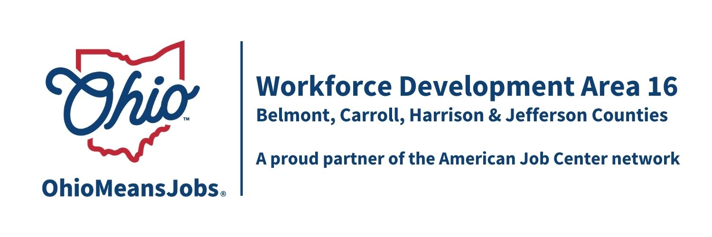
Workforce Development Board Meeting
12/5/25 10:00 am
GoToMeetings
Meeting Minutes

- Call to Order: Meeting called to order by Nicole Paulette, Board Chair at 10:04am.

- Roll Call by Rob Guentter

Board Member Attendees: Jeremy Morris, Ed Good, Crystal Lorimor, Jake Hershberger, Nicole Paulette, William Moore, Dave Wheeler, Kevan Brown, and Brian Palmer. Quorum established.

Non-Member Attendees: Mike Schlanz, Hope McAfee, Rebecca Safko, Rob Guentter, Jacob Barr, Rich Gualtiere, and Lisa Duvall.

- Virtual Meeting Policy
Rob reviewed the state law around virtual meetings. He noted that all votes require voice votes on all agenda items.

- Approval of Board 9/12/25 Minutes
Motion 22-2025 Motion to approve 9/12/25 Meeting Minutes
1st Good 2nd Wheeler

Roll Call Vote
Morris | Good | Lorimor | Hershberger | Paulette
Yes | Yes | Not heard | Yes | Yes
Moore | Wheeler | Brown | Palmer
Yes | Yes | Yes | Yes
Motion Approved

- Financial/Participants Reports and Transfers
Rebecca provided the financial report based on the October 2025 statement.
All expenditures are in line for this time of the year.
Transfers: None

Motion 23-2025 Motion to approve financial report.
1st Hershberger 2nd Brown

Roll Call Vote
Morris | Good | Lorimor | Hershberger | Paulette
Yes | Yes | Not heard | Yes | Yes
Moore | Wheeler | Brown | Palmer
Yes | Yes | Yes | Yes
Motion Approved

- WIOA Update
Rob Guentter shared a written Staff-to-the-Board report which included:

WIOA Update: Staff Report
- WIOA Reauthorization
- WDB16 2-year Board appointments/recertification
- OMJ Center Recertifications
- ARC ARISE Apprenticeship update.
- 4-year Youth Elements Assessment
- AI Eligibility and Tracking Project Special Grant request.
(match in-kind from staff, CCMEP links to pre apprenticeship, Navigators, and state workforce specialists)
- Industry Sector Partnership (ISP) Activity in WDA16

- Operator updates

Belmont Co: Mike Schlanz reviewed the Belmont Co data handout report. They currently have 4 adults set up for GRIT funded training but are still waiting for the final signed GRIT agreement. 34 businesses are using Belmont OMJ for job postings.

Carroll Co: Rob gave an overview of the OMJ including that client levels are stable, 17 businesses are using the OMJ for job search, and 14 youth are in ongoing CCMEP youth.
The OMJ is also continuing their VR Career Exploration outreach with Conotton Valley Schools.

Harrison Co: Jacob Barr shared that they are continuing to increase their CCMEP enrollment with 14 currently enrolled, of which 5 are in work experience. They have submitted their GRIT budget but are also still waiting for state approval.

Jefferson Co: Hope McAfee discussed their submitted written report and updated it that they had 85 walk-ins this past month. 31 of these needed help/information regarding unemployment insurance (UI). They are using their VR career exploration equipment with Indian Creek, Edison Local, Jefferson JVS, and Buckeye Local.

- OMJ Recertification: The Board discussed the Recertification Committee recommendation to approve the recertification of all 4 WDA16 OhioMeansJobs (OMJ) Centers. Paulette and Moore shared they had a good experience visiting all 4 OMJ Centers. They appreciated the dialog with staff and the committee (Nicole Paulette, Marc Manheim, William Moore, and Karla Martin) unanimously recommends approval of all 4 county OMJ Recertifications.

Motion 24-2025 Motion to approve the Recertification of OMJ Centers in Belmont, Carroll, Harrison, and Jefferson Cos., and to submit all related/required paperwork to the state.
1st Hershberger 2nd Lorimor

Roll Call Vote
Morris | Good | Lorimor | Hershberger | Paulette
Yes | Yes | Yes | Yes | Yes
Moore | Wheeler | Brown | Palmer
Yes | Yes | Yes | Yes
Motion Approved

- ARC-ARISE Apprenticeship Implementation Grant

Motion 25-2025 Motion to approve the submission of an ARC-ARISE Apprenticeship Implementation grant, and to provide $50,000 per year for up to five years, of in-kind support. 1st Brown 2nd Hershberger

Roll Call Vote
Morris | Good | Lorimor | Hershberger | Paulette
Yes | Yes | Yes | Yes | Yes
Moore | Wheeler | Brown | Palmer
Yes | Yes | Yes | Yes
Motion Approved

- Special Grant Request for AI Eligibility and Tracking project
Rob explained he would like the area to take the lead on an innovative AI driven mobile WIOA application and tracking system. He said he was working to involve other Workforce areas and their leadership in this project. Area 15 and 17 have already agreed to participate. Areas 1 and 8 are still considering. The Board discussed concerns about our capacity to lead such an effort, especially with Rob’s retirement in June 2026. The inclusion of other area leadership addressed this concern.

Motion 26-2025 Request a $175,000 Special Project grant from ODJFS to design and demonstrate an AI driven intake, eligibility determination, and monitoring /tracking program for Adult and Dislocated Worker clients, and to involve other workforce areas in this project. 1st Lorimor 2nd Wheeler

Roll Call Vote
Morris | Good | Lorimor | Hershberger | Paulette
Yes | Yes | Yes | Yes | Yes
Moore | Wheeler | Brown | Palmer
Abstained | Yes | Yes | Yes
Motion Approved

- 2026 WDB16 Proposed WDB16 Meeting Dates (all Fridays at 10am):

Motion 26-2025 to approve the following 2026 WDB16 Board Meetings:
3/13/26 GoTo; 6/5/26 In person in Cadiz; 9/11/26 GoTo; and12/4/26 TBD
1st Hershberger 2nd Good

Roll Call Vote
Morris | Good | Lorimor | Hershberger | Paulette
Yes | Yes | Yes | Yes | Yes
Moore | Wheeler | Brown | Palmer
Yes | Yes | Yes | Yes
Motion Approved

- Open Discussion

AWDA16 Cyber Security Policy: Rebecca shared that we have until June 2026 to develop a Cyber Security Policy under a new state requirement. Rob said he will work with Belmont Co ODJFS, who serves as our fiscal agent, to develop a plan for the March 2026 Board meeting. He will work with Nicole to create an ad hoc Board committee if needed.

13. Motion to Adjourn
Motion 27-2025 to adjourn.
1st Good 2nd Brown

Roll Call Vote
Morris | Good | Lorimor | Hershberger | Paulette
Yes | Yes | Yes | Yes | Yes
Moore | Wheeler | Brown | Palmer
Yes | Yes | Yes | Yes
Motion Approved

Next Other
Meeting: Fri March13, 2026 on GoToMeetings

Adjournment- 11:38am

____________________________________________________ ____________
Board Chair Date

