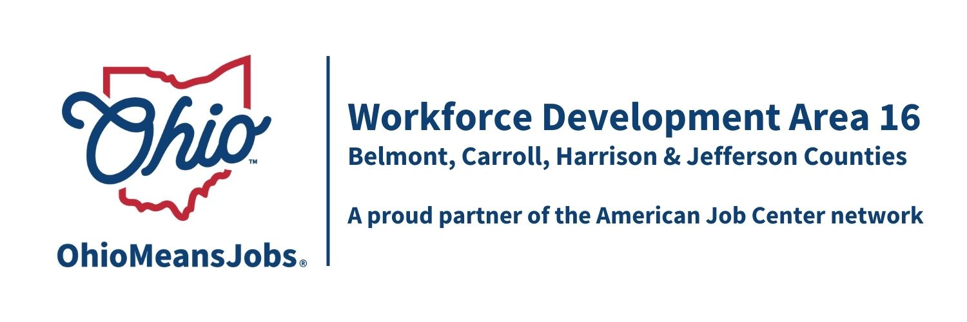
Staff to the Board Report 3.13.26 Rob Guentter AICP

WIOA Reauthorizations: While nothing is firm at the time of this writing, House and Senate committees have appeared to stall in any efforts for reauthorization. As WIOA has been refunded for another year at current levels, time will tell what happens. Congress has a lot of other pressing issues to address now!

WDB16 2-year Board appointments/recertification: All WDB16 Board members serve a 2-year term which goes to June 30, 2027. The State has approved the WDB16 Board member reauthorization to 1/13/28.

OMJ Center Recertifications: All 4 OMJ Centers have been approved and recertified by the State of Ohio. Thanks for everyone’s great work to accomplish this. Special thanks to the WDB16 committee which includes Marc Manheim, Karla Martin, Nicole Paulette, and William Moore.

4-year Youth Elements Assessment: Every 4 years we evaluate the needs and workforce preparation service gaps for area youth. Each county has evaluated the needs and gaps of the 14 required WIOA Youth Elements for their community with the following RFP priorities:
Belmont Co: Youth Work Experience, Leadership, Adult Mentoring
Carroll Co: Youth Work Experience, Leadership, Financial Literacy
Harrison Co: Youth Work Experience
Jefferson Co: Youth Work Experience, Leadership, Framework/Design

The WDA16 Executive Bd will evaluate all received proposals for recommendation to the full Board at the June 2026 WDB16 meeting. Pending approved funding, this will allow for implementation on 7/1/26. Contracts will be for 4 years, with annual renewal based on performance and available funding.

ARC ARISE Apprenticeship Update: A multi million letter of intent has been submitted to ARC to fund implementation of a tri-state Apprenticeship development and support program. If the letter is accepted, around April, the consortium will be invited to submit a full application. Implementation would likely begin in September 2026. Each of the 10 participating Workforce Areas (PA, OH and WV) have been asked to contribute up to $1,000 for the grant writer. This request is an action item on the agenda.

AI Eligibility and Tracking Project Special Grant request: With Board approval last meeting , we have submitted a $175,000 grant to design and demonstrate a mobile WIOA Adult and Youth project that will allow staff to focus on high value services and improve client experience. Our concept will allow client mobile application, which AI automated eligibility assessment. The system would also guide required monitoring, client interaction, and follow up. Staff would be required to approve all documents and case notes to link automatically to ARIES (state reporting system). Areas 1, 15, 16, and 17 jointly submitted the proposal to be a part of this demonstration project. No local funding, other than staff coordination, would be required. We see this as a viable demonstration effort that could be used statewide. WE have held meeting with state staff for more details, and the proposal is sitting with an “intrigued” ODJFS Director for his final say so. This project intersects with a big state effort to replace the ARIES reporting system.

Industry Sector Partnership (ISP) Activity in WDA16: The 4 counties in Area 16 are of the only counties in Ohio without Industry Sector Partnerships (ISPs). We are working to change that! Appalachian Ohio Manufacturers Council (AMOC), based in Marietta, is working to expand services into Belmont Co, and a consortium of WDB16, JobsOhio (OhioSE), OMEGA, and the Mahoning Valley Manufacturing Council (MVMC) are working to create an ISP to serve Jefferson, Carroll, and Harrison Cos. ISPs are business/industry led consortiums that see businesses working collaboratively for common good for things like shared safety training, coordinated purchasing, and apprenticeships. Agencies like OMJs are involved to meet the needs determined by the ISP. Business drives this process, and were they have business champions/leaders, this concept can result in more profitable companies and stronger workforces. The Jefferson, Carroll and Harrison group are considering applying for a $50,000 SPARK grant to help this effort. I understand OMEGA may be the lead and we would only need to provide a letter of support. Grant funding would be used to create a 501(c)3, develop a formal ISP Plan, and outreach to area businesses.

